Niner Talent User’s Guide: Temp Hire Manager Applicant Tracking

Table of Contents

Temp Hire Manager 3
Overview 3
Introduction 3
Purpose 3
How to Create a New Job Posting 3
How to Create a New Job Posting cont. 4
How to Create a New Job Posting cont. 5
How to Create a New Job Posting cont. 6
General Information Fields 8
How to Create a Guest User Account 9
How to Create Search Committee Members 10
How to Review an Applicant Pool 11
Introduction 11
Purpose 11
How to Review an Applicant Pool continued 12
How to Review an Applicant Pool continued 13
Applicant Tracking - Creating a Hiring Proposal 15
Introduction 15
How to Create a Hiring Proposal 15
How to Create a Hiring Proposal continued 16
How to extend an Offer of Employment……………………………………………..17

Temp Hire Manager

Overview

Introduction | The Applicant Tracking module is used to create job vacancies for Temporary positions; such as, part-time faculty, Temporary Staff, Student Temporary Wage, and Federal Work Study

Purpose | The Applicant Tracking module is used to:  - Post job vacancies  - Review the applicant pools

Applicant Tracking for Temp Hire Manager: Create New Job Posting

How to Create a New Job Posting
  Step | Action
  1 | Log into Niner Talent with your Niner Net user name and password.  Result: a green confirmation message will appear at the top of the screen.  Note: The menu may change based on your default settings.
    If ... | Then ...
    Your Home Page is not the Temp Hire manager User Group | Change your User Group to Temp Hire manager
    Your Home Page defaults to the Temp Hire manager User Group | Proceed to Step 2
  2
    If ... | Then ...
    The module does not default to Applicant Tracking | Change the module
    The module defaults to Applicant Tracking | Proceed to Step 3

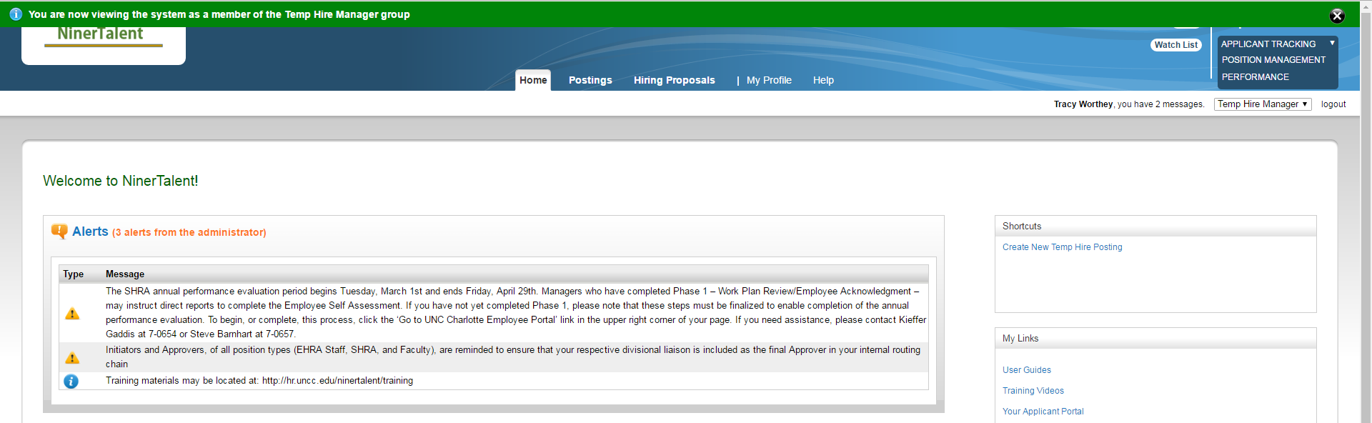

How to Create a New Job Posting cont.
  Step | Action
  3 | Click on the Posting tab and choose Temp Hire from the drop down menu.
  4 | Click Create New Postings.  Result: A Create New dialog box opens with three options.  Note: You will choose Create from Classification.
  5 | Choose Create from Classification.  Result: All approved temporary classifications will display.

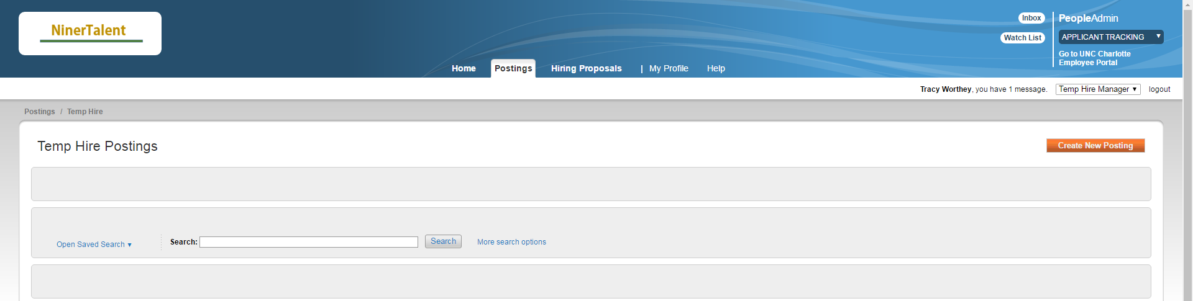

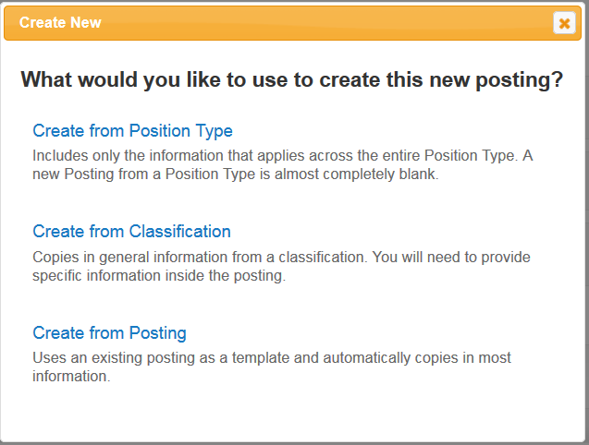

Continued on next page

Overview, Continued

How to Create a New Job Posting cont.
  Step | Action
  6 | Highlight the correct classification and click the down arrow next to the Action column.
  7 | Choose Create From.  Result: The New Posting page displays with prefilled information.

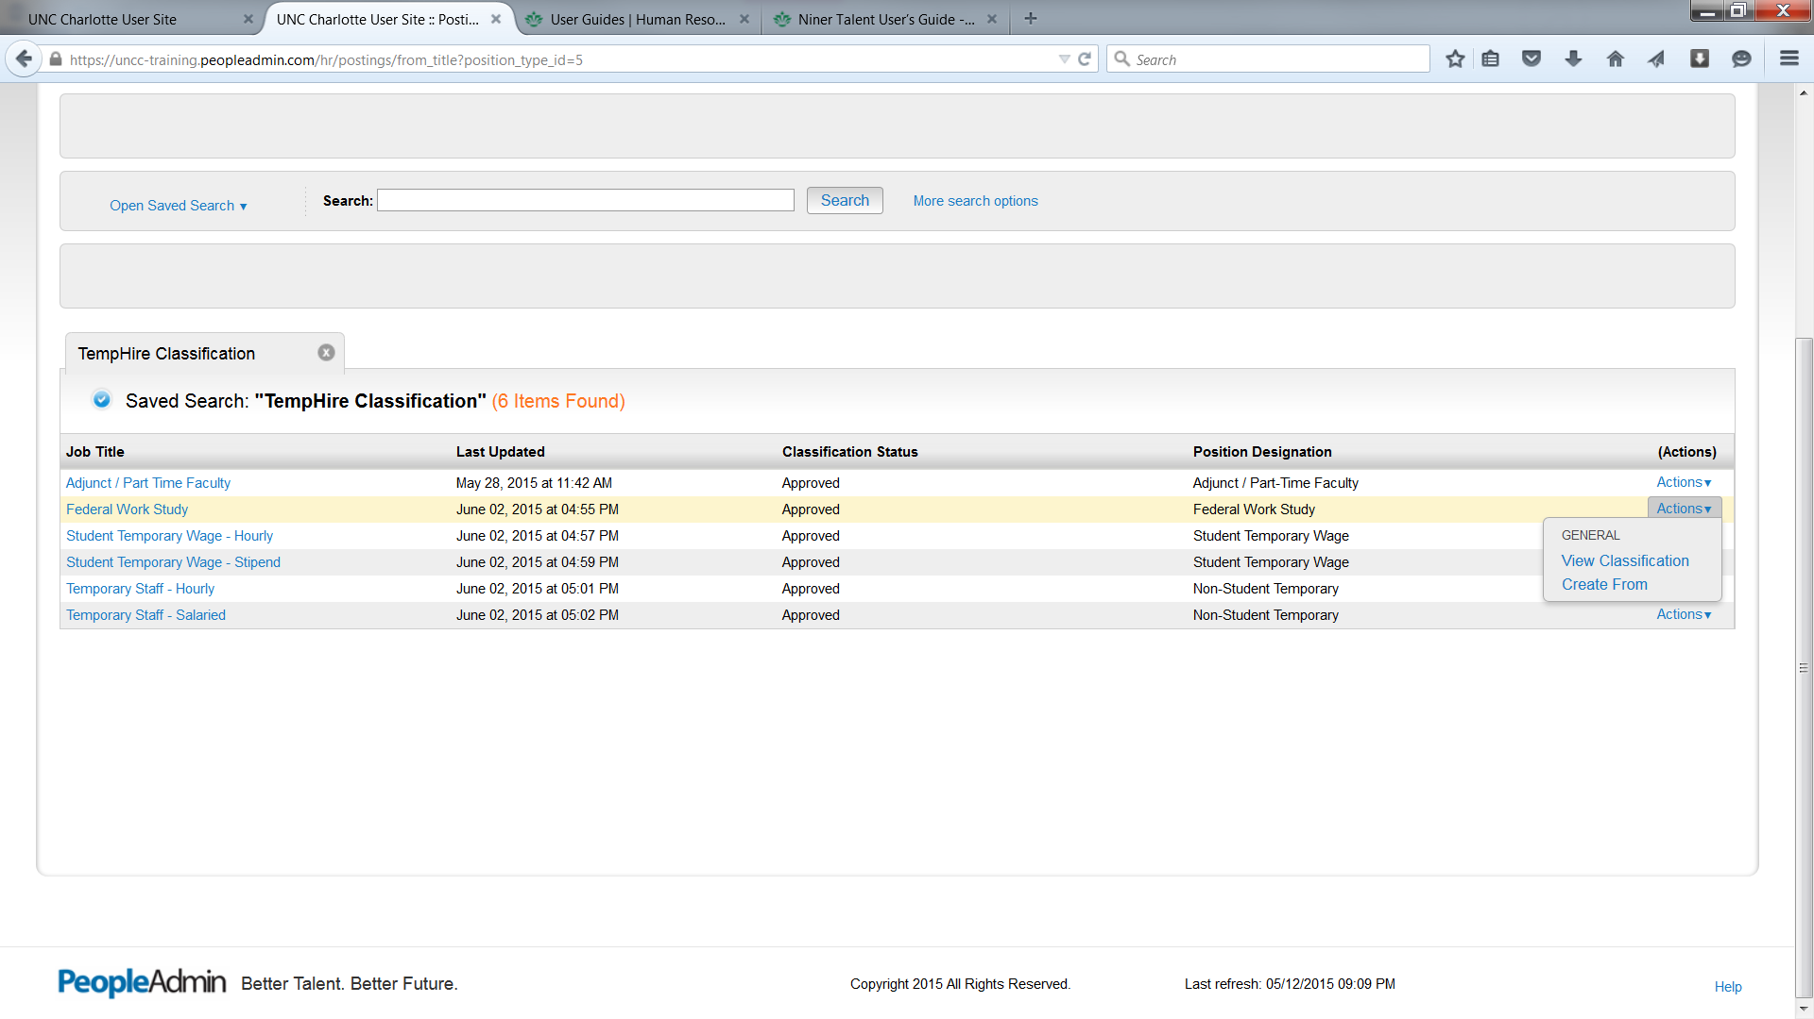

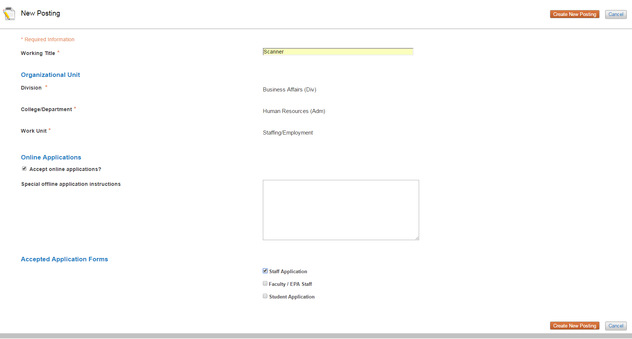

Continued on next page
Overview, Continued

How to Create a New Job Posting cont.
  Step | Action
  8 | Verify the correct Work Unit displays.  Note: If you support more than one unit, you will need to choose the appropriate one.
  9 | Verify that the Accept Online Application box is checked.  Select appropriate Accepted Application Forms.
  10 | Click Create New Posting.  Note: This button is at the bottom right of the screen.  Result: The General Information tab displays.
  11 | Complete all fields on the General Information tab as needed.
  12 | Click Save.
  13 | Click Next.  Result: The Applicant Document tab displays.  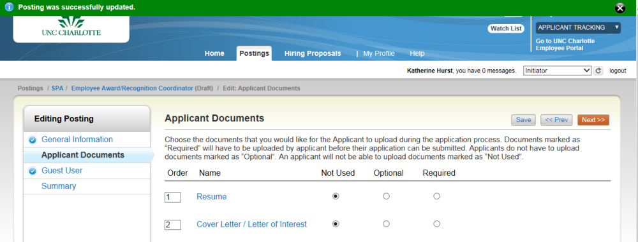
  14 | Select the documents you wish to include in the application.  Note: the default is Not Used. You will need to indicate if the document is optional or required.
  15 | Click Save.
  16 | Click Next.  Result: The Search Committee Members tab displays.
  17
    If ... | Then ...
    You wish to set up a Search Committee | See How to Set up a Search Committee.
    You do not wish to set up Search Committee | Go to step 18
  18 | Click Next.  Result: The Guest User tab displays.
  19
    If ... | Then ...
    You wish to create a Guest User | See How to Create a Guest User Account.
    You do not wish to create a Guest User account | Click the Summary tab.
  20
    If... | Then… | And Then…
    You wish to keep working | Save your information | Add it to your Watch List
    You are ready to submit for approval | Select HR (Move to HR) | Add it to your Watch List
  21 | Click Submit
Continued on next page

Overview, Continued
General Information Fields
  Audience | Definition
  All candidates | Open to anyone
  UNC Charlotte employees only | Permanent, probationary and time limited employees (does not include students or temporaries)
  State of NC employee only | Permanent, probationary and time-limited (does not include students, temporaries, community college employees and local K-12 school employees)
  UNC Charlotte students | Open only to students

Field Name | Description
Work Title | Must be entered as this is the title of the job that applicants will search on.
FLSA Designation | If requesting a Temporary Staff salaried position, must complete the FLSA exemption form and have it approved by HR, before creating your posting.
Hours per week | This will determine if the position is full-time (30-40 hours) or part-time (29 hours or less).
Pay Rate | For Students and Temporary Staff, a rate of pay must be listed to advertise to applicants.
Minimum Education/Experience | Indicates the minimum education and experience to be successful in this position. Departments must provide.
Departmental Preferred Experience | Description of what your ideal candidate would have in the way of knowledge, skills, and abilities. Should be more than the minimum requirements.
Duties and Responsibilities | Primary duties of the position that applicants would do on a regular basis.
Other Work Responsibilities | Items that are important, but done on a less frequent basis.
Necessary Licenses or Certifications | If this position requires any licenses or certification list it here. If it is optional/preferred, it should be listed in the Departmental Preferred field.
Expected Length of Assignment | Communicated to applicant, how long the assignment will last.
Posting Open and Close Dates | Used by departments to indicate future open dates and longer close dates. Otherwise, posting will post when received.
Contact Information | Will be seen by the applicant.
Special Notes to Applicant | Used by the departments to convey vital information to the applicant.
Advertising | Used to indicate the advertising methods used.

Overview, Continued

How to Create a Guest User Account | If you are using a search committee or have other assisting with the recruitment, you can set up guest user access.
  Step | Action
  1 | Select the Guest User tab.  Result: The Guest User page displays.  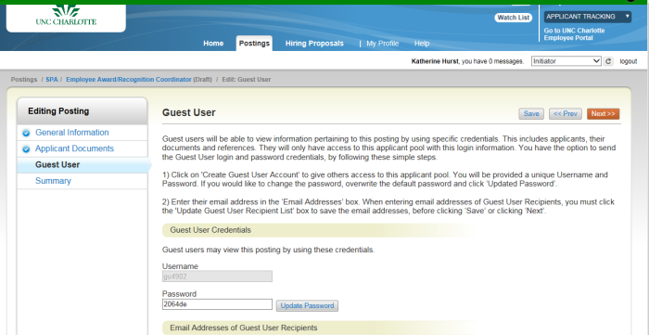
  2 | Verify the user name and password.  Note: You can update/change the password if you wish.
  3 | Enter the guest user’s email address.
  4 | Click Update Guest User Recipient List.
  5 | Click Next to move to the Summary tab.
  6
    If… | Then… | And Then…
    You wish to keep working | Save your information | Add it to your Watch List
    Additional Approval is required | Select Approver (Move to Approver) | Choose the appropriate approver from the drop down box and click
    Additional approval is not required | Select HR (Move to HR)
Continued on next page

Overview, Continued

How to Create Search Committee Members | If you are using a search committee or have other assisting with a faculty recruitment, you can use Search Committee Member to organize the committee.
  Step | Action
  1 | Select the Search Committee Members tab.  Result: The Search Committee Members page displays.  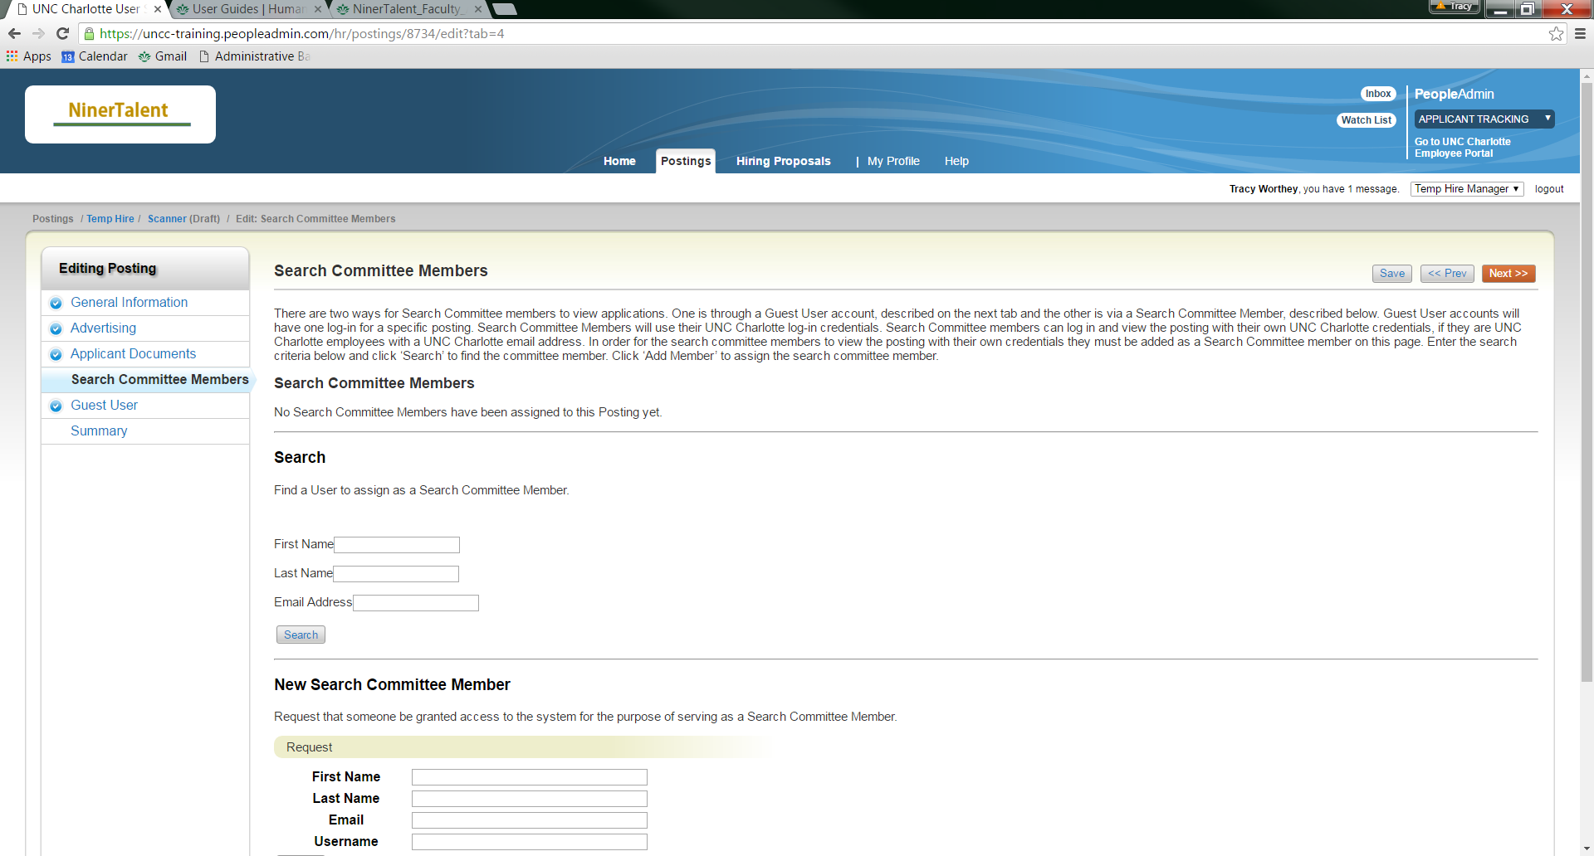  Note: All faculty have been given access to the search committee member user group.
  2 | Enter: their first and last name or email address
  3 | Click Search
  4 | Result: If an account is found, Click Add Member  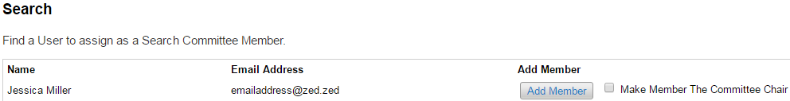
  5 | If the person is not found, contact Jessica Miller at 7-5771 in Academic Affairs.
  6 | You can mark one member the Committee Chair, by clicking the box Make Member the Committee Chair

Applicant Tracking – Review Applicant Pool

Introduction | Once the posting has been approved by either Academic Affairs for part-time Faculty; HR Employment for Temporary Staff; or Student Employment for Student postings, applicants will appear in your queue, as they apply. You can then review your applicant pool and make a decision on your applicants as they apply.

Purpose | In this section, Temp Hire Manage will learn how to review applicants, change the statuses of unsuccessful candidates and move the successful candidate to a recommend for hire status.

How to Review an Applicant Pool
  Step | Action
  1 | Log into Niner Talent with your Niner Net user name and password.
    If ... | Then ...
    Your Home Page is not the Temp Hire Manager User Group | Change your User Group to Temp Hire Manager
    Your Home Page defaults to the Temp Hire Manager User Group | Proceed to Step 2
  2
    If ... | Then ...
    The module does not default to Applicant Tracking | Change the module
    The module defaults to Applicant Tracking | Proceed to Step 3
  3 | Click on the Postings tab and select Temp Hire from the drop down list.  Result: The Posting Summary tab displays.
  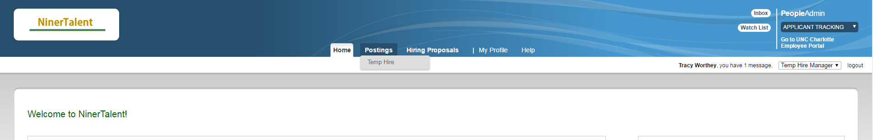
Continued on next page
Applicant Tracking – Review Applicant Pool Continued

How to Review an Applicant Pool continued
  Step | Action
  4 | Select the working title of the position you wish to review.
  Click on the Applicants tab.
  Result: The Posting will display all of the applicants for that posting.
  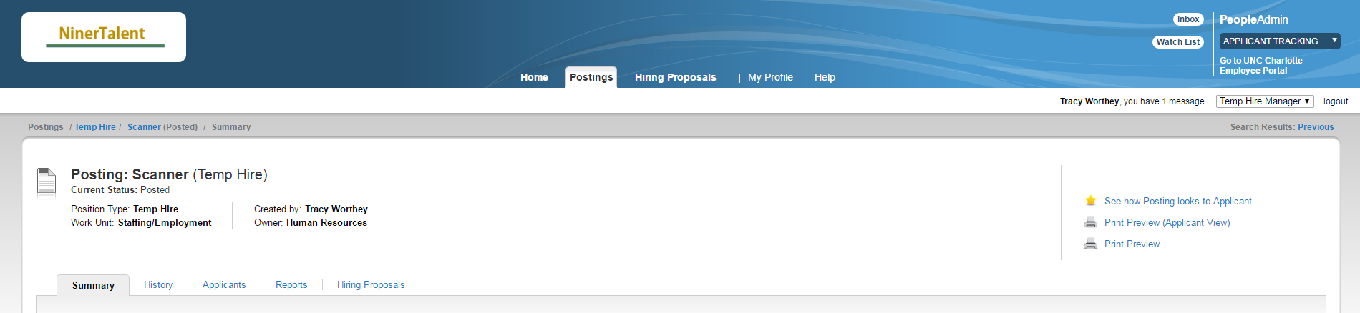
  5 | Click on the name of the applicant you wish to review.  Result: The Job Application displays.
  6
    If ... | Then ...
    You wish to see supplemental documents | Scroll to the bottom of the page and select View under Combined Documents
    You do not wish to see supplemental documents | Proceed to the Step 7
  7 | Click Take Action on Job Application.  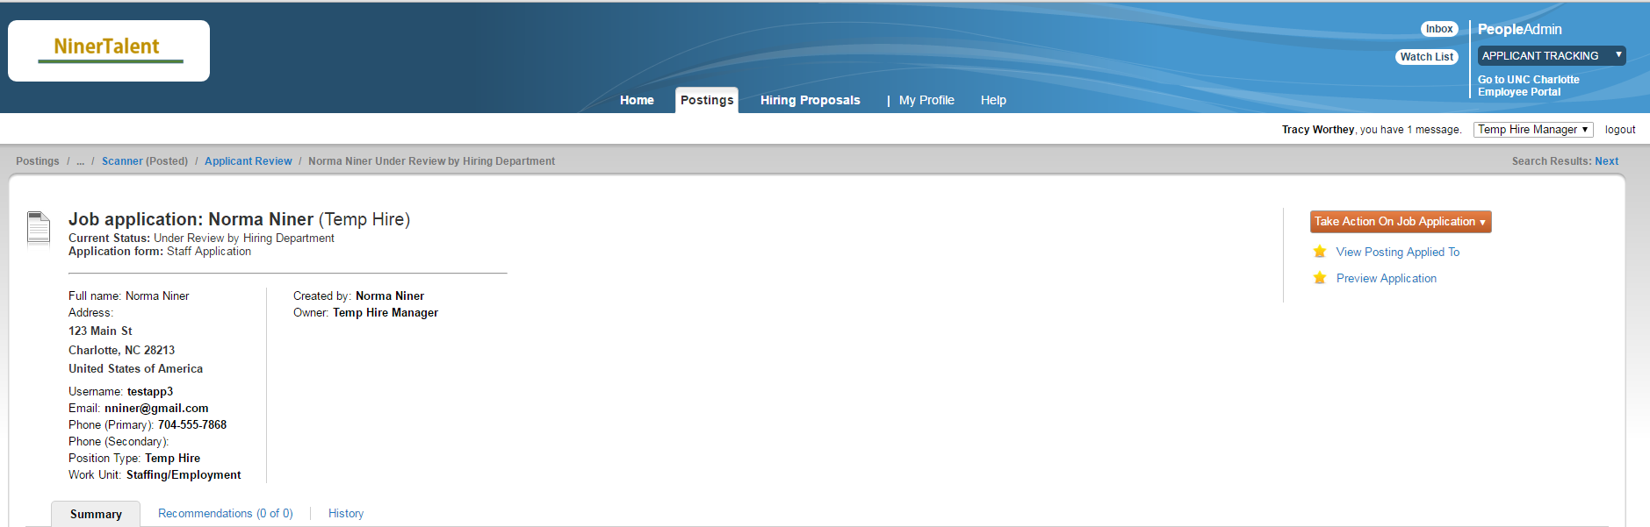
Continued on next page

Applicant Tracking – Review Applicant Pool Continued

How to Review an Applicant Pool continued
  Step | Action
  8
    If | Then
    You are recommending the candidate | Change status to Send to Recommended for Hire  Result: The Start Hiring Proposal option appears in the Take Action on Job Application section.
    You are not recommending for hire | Choose the appropriate workflow action
  9 | To move to the next applicant, click Next at the top of the page.  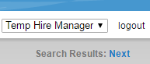
  10 | Review all additional applicants as needed.
  11 | Click Take Action on Job Application and change the applicant status to the appropriate work flow actions:  Ex: Recommended for hire
  12 | At this time, if the posting does not have a close date, inform HR/Academic Affairs to close your posting.
Continued on next page

Applicant Tracking – Review Applicant Pool Continued

Take Action on Job Applicant Status

Work Flow Actions | Description
Send to Further Consideration | Select for applicant on the short list, who have a possibility of an interview. (Faculty recruitment)
Send to Not Best Qualified | Document how the applicant did not meet the job selection criteria
Send to Not Current University Student | Not currently enrolled at UNC Charlotte as a degree seeking student. (Student recruitment)
Recommend for Hire | Chosen candidate and the status the applicant will need to be in to begin the hiring proposal.

Applicant Tracking - Creating a Hiring Proposal

Introduction | The Create Hiring Proposal action identifies the candidate(s) selected for the posted position.

How to Create a Hiring Proposal
  Step | Action
  1 | Click the candidate’s name from the Applicants tab.
  2 | Change the applicant’s status to Send to Recommend for Hire  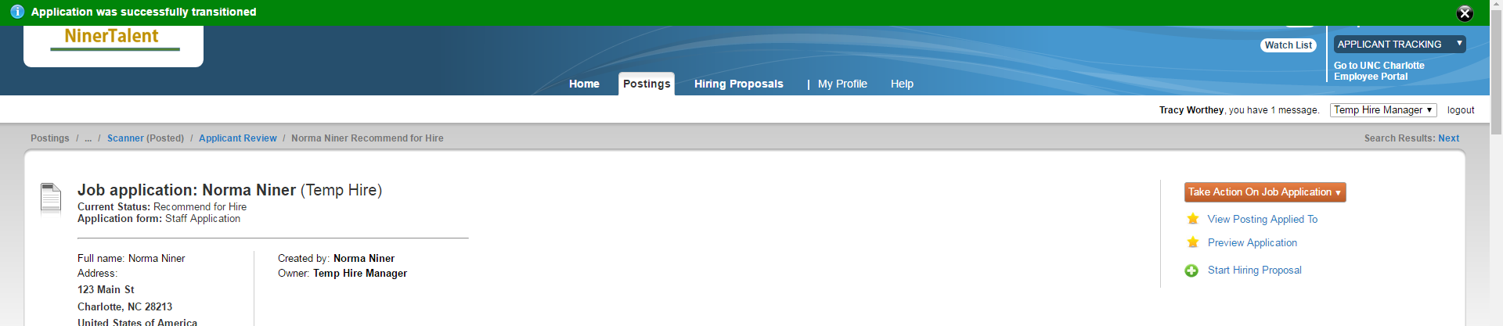  Result: Start Hiring Proposal link will appear.
  3 | Click Start Hiring Proposal.  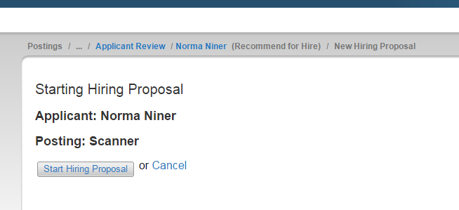  Result: The Hiring Proposal displays.
Continued on next page

Applicant Tracking - Creating a Hiring Proposal, Continued

How to Create a Hiring Proposal continued
  Step | Action
  4 | Complete all required fields.
  5 | Click Next to move through the remaining tabs.
  6 | From the Summary tab, click Take Action on the Hiring Proposal.
    If… | Then… | And Then…
    You wish to keep working | Save your information | Add it to your Watch List
    Additional Approval is required | Select Approver (Move to Approver) | Choose the appropriate approver from the drop down box and click on their name
    Additional approval is not required | Select HR (Move to HR)
  7 | Add comments and click Submit.  Note: Once reviewed and approved by Human Resources, you will receive an email notification to extend an offer of employment and to submit an EPAF.
  8 | Contact the candidate to extend the offer of employment.
    If ... | Then ... | And Then…
    Yes | Proceed to How to Extend an Offer of Employment procedure
    No | Inform HR to cancel the hiring proposal. | Move to second choice candidate or repost position.

Continued on next page

Applicant Tracking – How to extend an offer of employment

Introduction | Once the candidate has accepted the offer of employment, you will need to complete an electronic personnel action form (EPAF).  For step by step process on how to complete an EPAF, lease review the Temporary Staff EPAF Manual at http://hr.uncc.edu/recruitment-and-hiring/temporary

