Hiring Temporary Staff Employees using Banner EPAFs

Version 3.0 – September 2021
© UNC Charlotte Human Resources

Contents
EPAF Defined 3
EPAF Access 3
Completing a Temporary Staff hourly EPAF 4
Section 1: Employee Information 8
Section 2: Job Assignment Information 9
Section 3: Job Termination 10
Section 4: Funding Information 11
Section 5: Routing Queue 12
Section 6: Comments 13
Finishing up… 13
Who to Contact 13
Completing a Temporary Staff salaried EPAF 14
Section 1 Employee Information 16
Section 2: Job Assignment Information 17
Section 3: Job Termination 18
Section 4: Funding Information 19
Section 5: Routing Queue 20
Section 6: Comments 22
Finishing up… 22
Who to Contact 22
Appendix 23
What a completed temporary staff hourly EPAF looks like. 23
What a completed temporary staff salaried EPAF looks like. 25
Things to know 27
Checking the status of your EPAF 27
Return for corrections 28

EPAF Defined
An Electronic Personnel Action Form is a Banner Self Service form, which allows you to submit recommendations for hire to the Human Resources office. Once the form is completed, submit it to the appropriate approvers. Once all approvers have approved the employment action, the EPAF is applied to Banner and the employee is set up for payroll.
Some advantages to using EPAFs:
- Paperless process for newly hired temporary staff employees; this relaxes the workload for both your department and Human Resources / Payroll
- Less chance of processing errors

EPAF Access
To request EPAF access, please go to our website and complete the EPAF Access Request Form, found at https://hr.charlotte.edu/forms/electronic-forms.
Once the request for access is processed and approved, you will be able to login to Banner Self Service to submit EPAF transactions. To access the EPAF menu, click on the Employee Information link or the Employee tab.
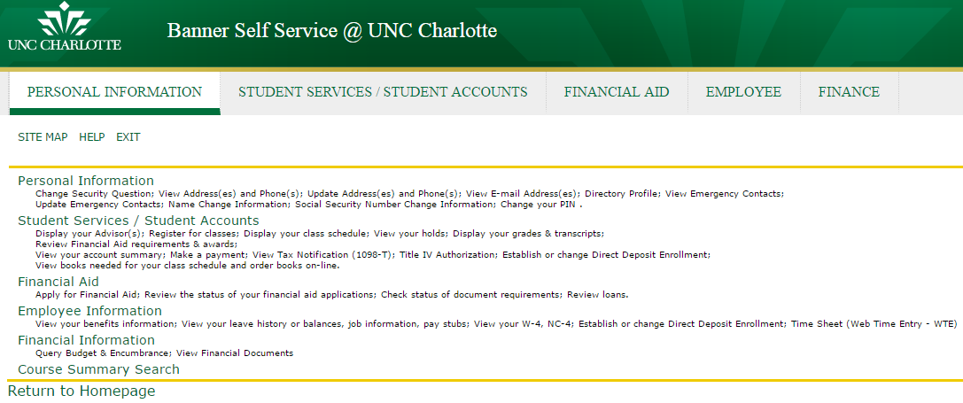
Figure 1 - Employee Information

Click on the link for EAPF – Electronic Personnel Action Form. If you do not see the EPAF link, you do not have access to create an EPAF. Please go to https://hr.charlotte.edu/forms/electronic-forms to request access.
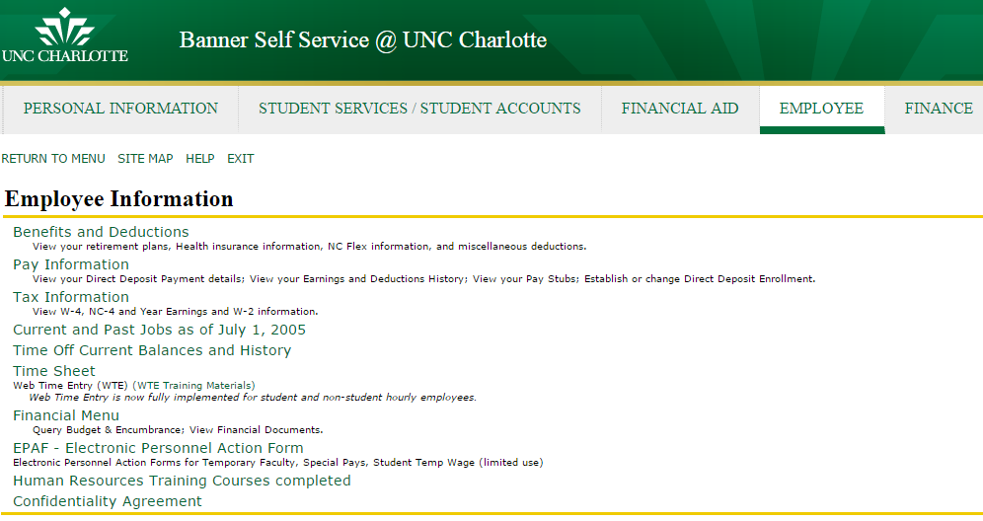
Figure 2 - EPAF Menu Item

Completing a Temporary Staff hourly EPAF
This section of the guide will walk you through the process of creating an EPAF for a temporary staff hourly employee.
First, select New EPAF (Figure 3).
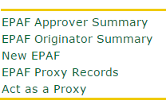
Figure 3 - New EPAF

To start the form, (Figure 4) input the employee’s UNCC ID number. If you do not know their ID number, click on the search icon to search by name.
Please note that you must change the Query Date to the first of the pay period, based on the employee’s start date. The system will default the query date to the day on which you are completing the EPAF. Please download the EPAF Submission Calendar to select the appropriate query date, based on the employee’s start date.

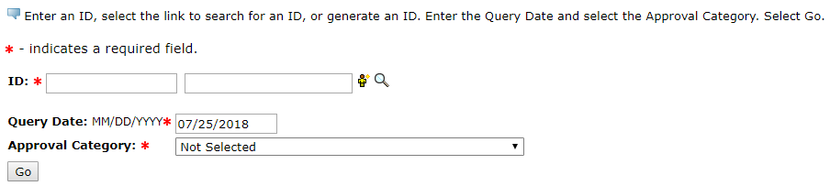
Is the first of the pay period, based on the start date.
Figure 4 – Query Date

If this is a new hire (never worked at the University before), select “Hire Non-Student Temporary Employee, N15”, then select “Go”.

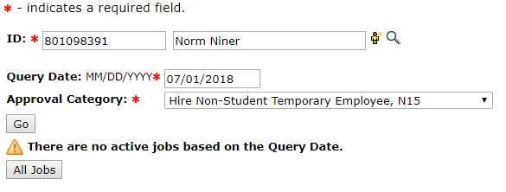
Figure 5 – Approval Category

If they are a rehire then select “Rehire Non-Student Temporary Employee, N15R”, then select ‘Go’.
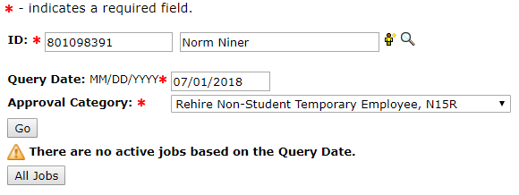
Figure 6 – Approval Category
Once you have selected the person you want to hire, the next screen will allow you to create a new job assignment (Figure 5):
Enter STMP15 in the position field.
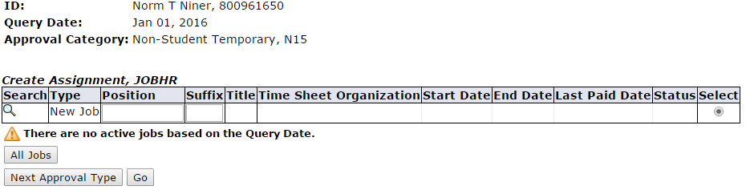
Figure 7 – Position Field
The Approval Category, entered on the initial screen, must match the Position number entered on this screen (Figure 5). A mismatch will cause the EPAF to error out or post incorrectly in Banner.
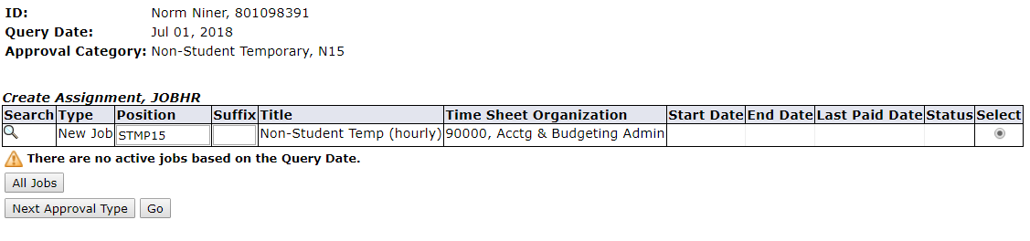
These two numbers must match!
Figure 8 – Position Field
For new hires, the suffix is always 00. Enter 00 in the suffix field (Figure 9). There should not be any active job(s) in the system.
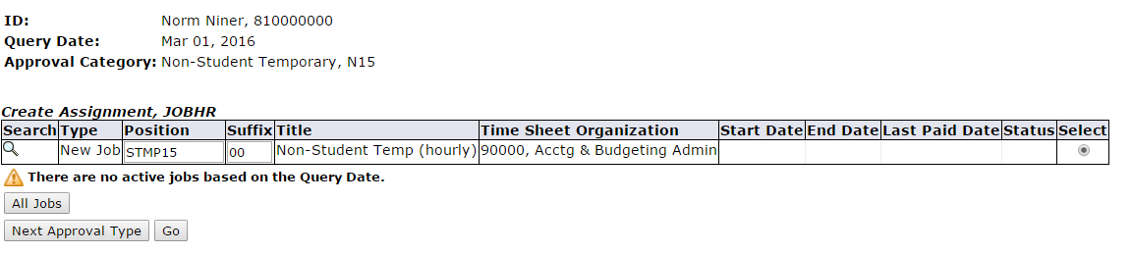
Figure 9 - Suffix
If the employee has a current position, it will be listed on this screen. If they have a (primary) job assignment listed, your entry will have to be secondary.
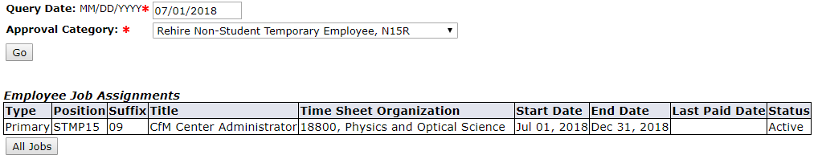
Figure 10 – Employee Job Assignments
To determine what suffix number to use for rehires, click on ‘All Jobs’, to review all the employee’s job records. Search all STMP15 jobs to identify the highest number used.
For example, if the highest suffix for STMP15 is 01, you will enter 02 when creating the new assignment. Please note you will not see pending actions. Therefore, EPAFs can be returned/disapproved because that suffix number has already been used.

Figure 11 – Other Active Jobs
To continue creating a new assignment for the temporary, click the Go button.
On the next screen, you will complete the form requiring all the necessary information about the employee’s new job (Figure 12).

Section 1: Employee Information
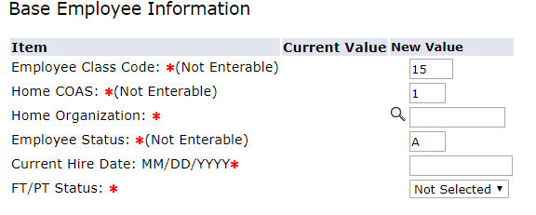
Figure 12 – Base Employee Information
Definitions of Item fields
Employee Class Code | This value indicates the type of temporary job. This is always 15, which represents a temporary hourly wage. This employee type must complete timesheets and have them approved by their supervisor.
Home COAS | Where the employee will work: currently the only supported value is 1, which indicates UNC Charlotte.
Home Organization | The organization number for department this employee will work in, assigned building access and drives (not the fund they will be paid from). This is the five-digit Banner organization number.
Employee Status | Not editable. This will always be set to “A” for Active.
Current Hire Date | This is the day the employee will begin work.
FT/PT Status | This indicates if the employee is Full Time (30-40 hours a week) or Part Time (29 or less hours a week).

Section 2: Job Assignment Information
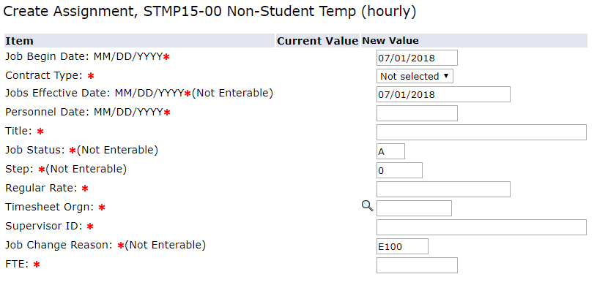
Figure 13 - Create Assignment

Definitions of Item fields
Job Begin Date | For Payroll purposes, this is the first day of the pay period, based on the employee’s start date. Should match the query date. To select the appropriate pay period, please download the EPAF Submission calendar.
Contract Type | If the employee currently has no other active job, set this field to Primary. If they do have another active job, set this field to Secondary.
Jobs Effective Date | Same as the Job Begin Date and Query Date.
Personnel Date | The date the employee actually begins work and should match the Current Hire Date.
Title | The employee’s job title.
Job Status | Not Editable
Step | Not Editable
Regular Rate | The employee’s hourly pay rate. Enter without $ (ex. 7.25)
Timesheet Org | The organization number where this employee will work. This is the five-digit Banner organization number. Should be the same as the Home Organization in the Base Employee Information section.
Supervisor ID | The UNCC ID number of the Web Time Entry (timesheet) approver.
Job Change Reason | Will always read as E100 for a new hire or E102 for a rehire.
FTE | Full Time Equivalent is the number of hours the employee will work per week. For the full list go to https://hr.charlotte.edu/recruitment-and-hiring/temporary.  40 hrs. – 1 25 hrs. - .625 10 hrs. -.25

Section 3: Job Termination
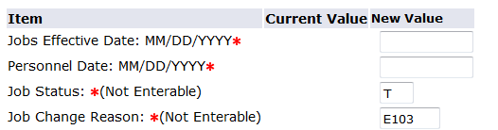
Figure 14 - Assignment End Date

Jobs Effective Date | For Payroll purposes, this is the last day of the pay period in which the employee worked. To select the appropriate pay period, please download the EPAF Submission calendar.
Personnel Date | This is the ACTUAL last day of work for the employee.
Job Status | This will always read as T, for Terminated.
Job Change Reason | Will always read E103.

Section 4: Funding Information
On this screen, the Effective Date should auto-populate and should match the Query Date. You must have your fund number and account number available. Remove the fund number that auto-populated and type the fund number in the INDEX field on the form, then click the “Default from Index” button below.
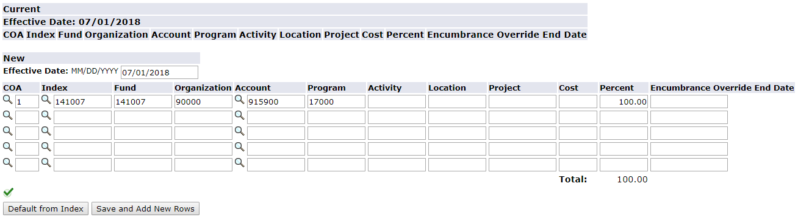
Figure 15 – Funding Information
You will receive an error message “account code is required”.
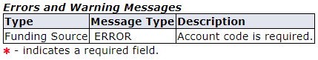
Figure 16 – Funding Errors
Retype the account number (915900) into the “Account” field (Figure 17) and move on to the routing queue.
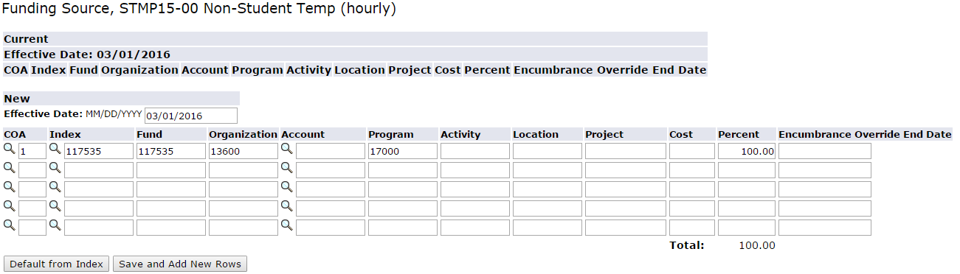
Figure 17 – Entering Funding Information

Section 5: Routing Queue
In this section, you will designate approvers for the EPAF (Figure 12). The appropriate users must approve all Temporary Staff EPAF transactions before they can be applied to the Banner HR database and be added to the payroll. Depending on your department’s policies, you may also need to add additional approvers. At least one approver beyond the initiator is recommended before an action is moved to HR.
Select the following mandatory approvers for each Temporary EPAF:
- Payroll – Click the magnifying glass and select Defaulted name
- Non-Student Employment – Click the magnifying glass and select Defaulted name
- Human Resources – Click the magnifying glass and select AppWorx (BANWORX)
- Fund approval, if grant funded
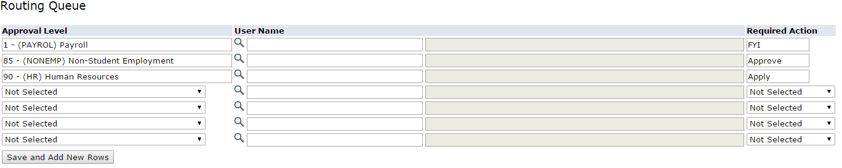
Figure 18 – Routing Queue Information
To add an additional approver, under approval level and select (DEPT) Department. Then click on the search icon for a pop window of approved Users. You can also enter their name in the search box and click ‘Go’. Then highlight their name and click ‘Select’. (Figure 19)
Figure 19 – Selecting a Department Approver
Under ‘Required Action’ chose, if they should ‘Approve’ or be “FYI. Approve will require them to approve the action to move on. FYI will allow them to see the action, only.
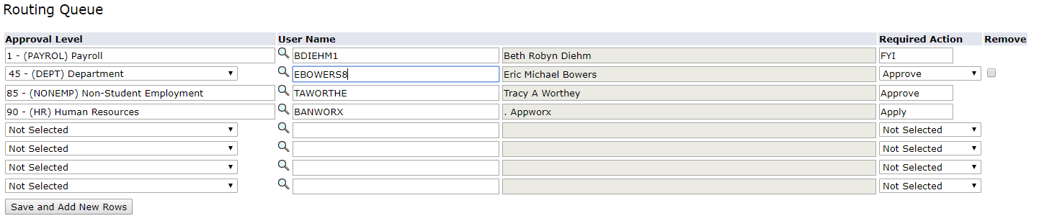
Figure 20 – Routing Queue

Section 6: Comments
In the comments section, provide a brief description of the position’s duties and responsibilities.

Finishing up…
Once the EPAF form is complete, click on the Save button, correct any errors that may appear (warning messages can be ignored, but you cannot submit the EPAF if there are errors). Then click on the submit button, and correct any additional errors. The EPAF will be applied by the Human Resources department, which is checked every day at 10 am and 3 pm.

Who to Contact
If you have any questions regarding EPAFs, please go to https://hr.charlotte.edu/recruitment-and-hiring/temporary for your Employment Consultant.

Completing a Temporary Staff salaried EPAF

To start the form, (Figure 21) input the employee’s UNCC ID number. If you do not know their ID number, click on the search icon to search by name.
Please note: that the system will default the query date to today’s date. You must change the Query Date to the beginning of the pay period the 1st or 16th, based on when the employee starts work. For example, if the employee’s first day of work is August 6, the query date will be the first. If their first day of work is August 27, the Query Date will be the sixteenth.
Query date for salaried is the 1st or 16th.
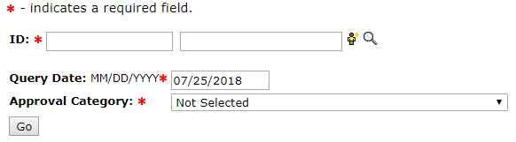
Figure 21 – Query Date

If this is a new hire (never worked at the University before), select “Hire Non-Student Temp (Salary), N18” then select ‘Go’.
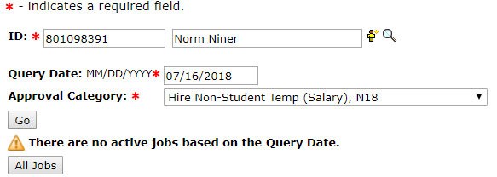
Figure 22 – Approval Category

If they are a rehire then select “Rehire Non-Student Temp (Salary) N18R”, then select ‘Go’.
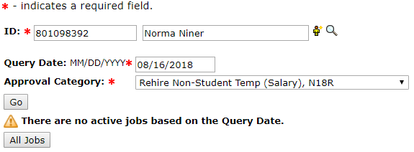
Figure 23 – Approval Category

Once you have selected the person you want to hire, the next screen will allow you to create a new job assignment (Figure 24):
Enter STMP18.
The Approval Category, entered on the initial page must match the position number entered on this screen (Figure 5). A mismatch will cause the EPAF to error out or post incorrectly in Banner.
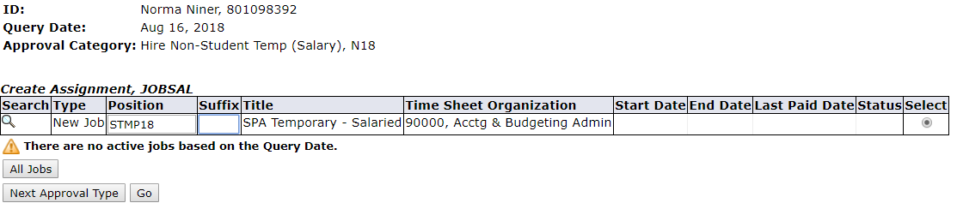
These two numbers must match!
Figure 24 – Position Field

For new hires (never worked at the University before), the suffix is always 00. Enter 00 in the suffix field (Figure 25). There should not be any active job(s) in the system.
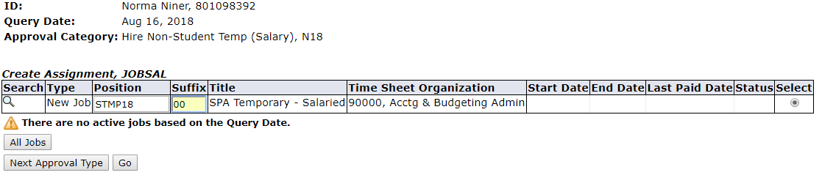
Figure 25 – Suffix

If the employee has a current position, it will be listed on this screen. If they have a (primary) job assignment listed, your entry will have to be secondary.
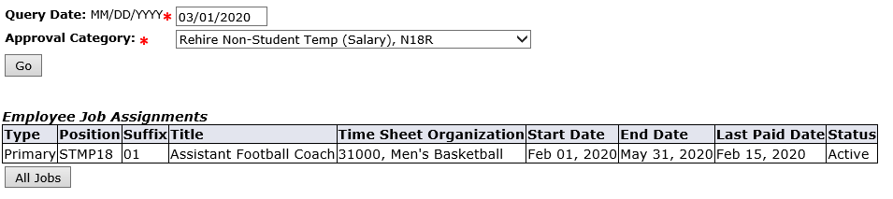
Figure 26 – Suffix
To determine what suffix number to use for rehires, click on ‘All Jobs’, to review all the employee’s job records. Search all STMP18 jobs to identify the highest number used.
For example, if the highest suffix for STMP18 is 01, you will enter 02 when creating the new assignment. Please note you will not see pending actions. Therefore, EPAFs can be returned/disapproved because that suffix number has already been used.
To continue creating a new assignment for the temporary, click the Go button.

Section 1 Employee Information
On the next screen, you will complete the form requiring all the necessary information about the new assignment (Figure 27).
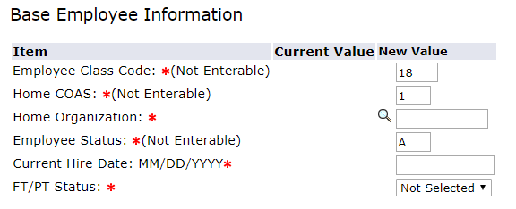
Figure 27 – Base Employee Information

Definitions of Item fields
Employee Class Code | This value indicates the type of temporary job. This is always 18, which represents a temporary salaried wage. This employee does not complete time sheets, but this assignment must meet FLSA exemption requirements.
Home COAS | Not editable: 1 - indicates UNC Charlotte.
Home Organization | The organization number for department this employee will work in, assigned building access and drives (not the fund they will be paid from). This is the five-digit Banner organization number.
Employee Status | Not editable: This will always be set to “A” for Active.
Current Hire Date | This is the day the employee will begin work.
FT/PT Status | This indicates if the employee is Full Time (30-40 hours a week) or Part Time (29 or less hours a week).

Section 2: Job Assignment Information

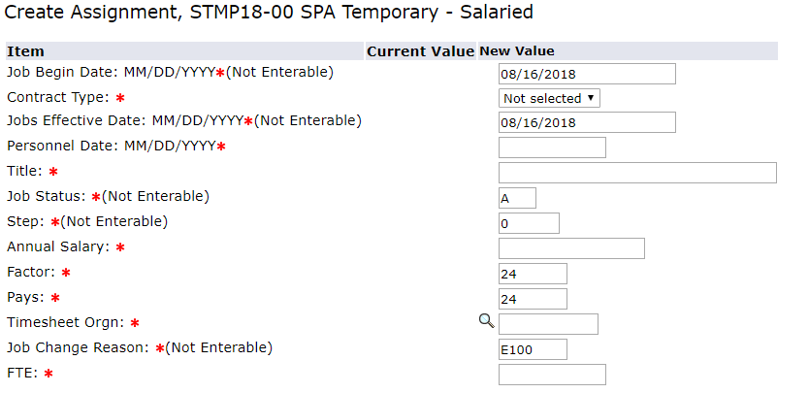
Figure 28 – Create Assignment

Definitions of Item fields
Job Begin Date | For Payroll purposes, this is the beginning of the pay period, which is the 1st or 16th of the month, in which the employee is hired. This should match the Query Date.
Contract Type | If the employee currently has no other active job, set this field to Primary. If they do have another active job, set this field to Secondary.
Jobs Effective Date | Same as the Job Begin Date and Query Date.
Personnel Date | The date the employee actually begins work and should match the Current Hire Date.
Title | The employee’s job title.
Job Status | Not Editable
Step | Not Editable
Annual Salary | The salary amount the employee will be paid during the duration of their assignment. Only enter numbers (Ex. 12800).
Factor | The number of pay periods during the length of the assignment. (24 is the default for a full year) These employees are paid twice a month. Ex. A three months assignment will have 6 pay periods.
Pays | Same as factor. These numbers must match.
Timesheet Org | The organization number where this employee will work. This is the five-digit Banner organization number. Should be the same as the Home Organization in the Base Employee Information section.
Job Change Reason | Will always read as E100 for a new hire or E102 for a rehire.
FTE | Full Time Equivalent is the number of hours the employee will work per week. For the full list go to https://hr.charlotte.edu/recruitment-and-hiring/temporary  40 hrs. – 1 25 hrs. - .625 10 hrs. -.25

Section 3: Job Termination

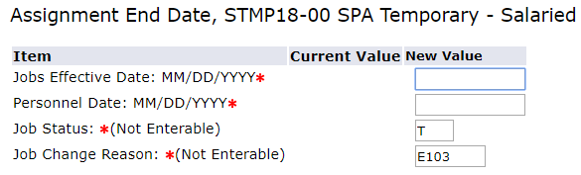
Figure 29 – Assignment End Date

Jobs Effective Date | For Payroll purposes, this is the last day of the payroll period, based on the employee’s last day of work. It is either the 15th or the last day of the month. Ex. If the personnel date falls during the 1-15, the effective date is the 15th of the month. If the personnel date falls during the 16 – end of the month, the effective date is the last day of the month.
Personnel Date | This is the ACTUAL last day of work for the employee
Job Status | This will always read as T, for Terminated.
Job Change Reason | Will always read E103.

Section 4: Funding Information
On this screen (Figure 30), the Effective Date should auto-populate and should match the Query Date. You must have your fund number and account number available. Remove the fund number that auto-populated and type the fund number in the INDEX field on the form, then click the “Default from Index” button below.
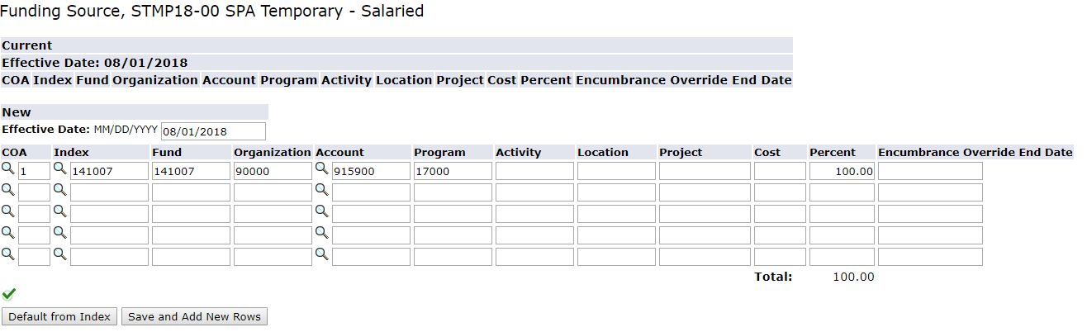
Figure 30 – Funding Source
You will receive an error message “account code is required”.
Figure 31 – Funding Errors
Then retype the account number (915900) into the “Account” field (Figure 32) and move on to the routing queue.
Figure 32 – Entering Funding Information

Section 5: Routing Queue
In this section, you will designate approvers for the EPAF (Figure 33). The appropriate users must approve all Temporary Staff EPAF transactions before they can be applied to the Banner HR database and be added to the payroll. Depending on your department’s policies, you may also need to add additional approvers. At least one approver beyond the initiator is recommended before an action is moved to HR.
Select the following mandatory approvers for each Temporary EPAF:
- Payroll – Click the magnifying glass and select Defaulted name
- Non-Student Employment – Click the magnifying glass and select Defaulted name
- Human Resources – Click the magnifying glass and select AppWorx (BANWORX)
- Fund approval, if grant funded

Figure 33 – Routing Queue Information
To add an additional approver, under approval level and select (DEPT) Department. Then click on the search icon for a pop window of approved Users. You can also enter their name in the search box and click ‘Go’. Then highlight their name and click ‘Select’. (Figure 34)
Figure 34 – Selecting a Department Approver
Under ‘Required Action’, chose if they should ‘Approve’ the assignment. By selecting FYI, they can review the EPAF, but will not be required to approve.

Figure 35 – Routing Queue

Section 6: Comments
In the comments section, provide a brief description of the position’s duties and responsibilities.

Finishing up…
Once the EPAF form is complete, click on the Save button, correct any errors that may appear. Warning messages can be ignored, but you cannot submit the EPAF if there are errors. Then click on the submit button, and correct any additional errors. The EPAF will be applied by the Human Resources department, which is checked every day at 10 am and 3 pm.

Who to Contact
If you have any questions regarding EPAFs, please go to https://hr.charlotte.edu/recruitment-and-hiring/temporary for your Employment Consultant.

Appendix

What a completed temporary staff hourly EPAF looks like.
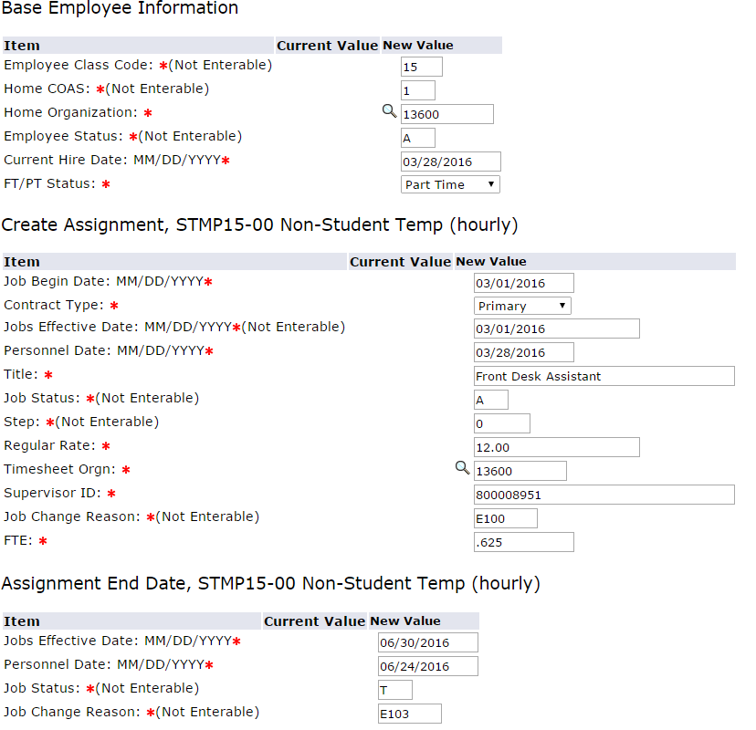
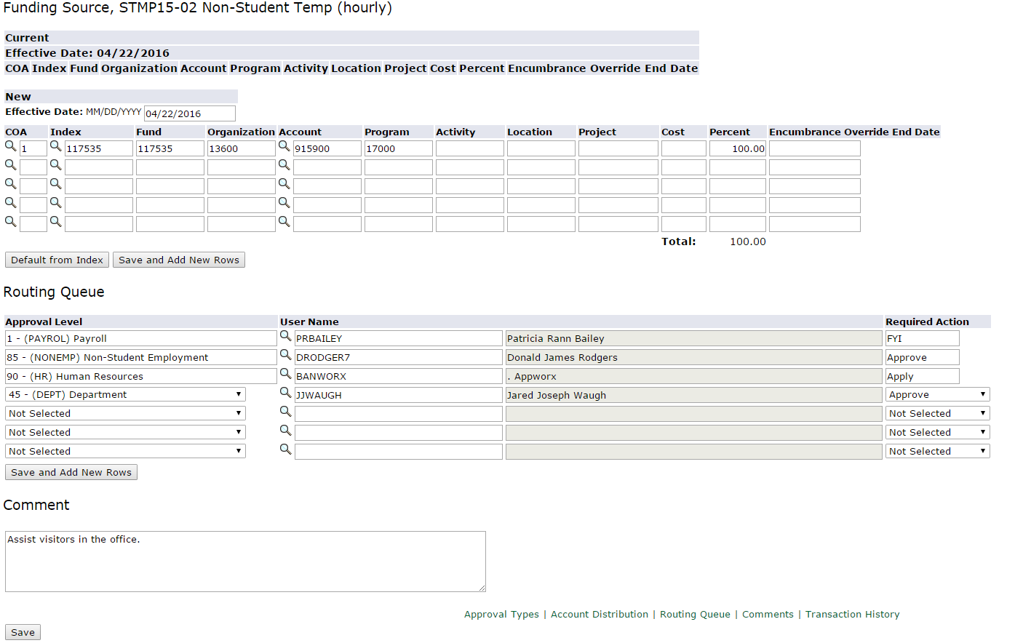

What a completed temporary staff salaried EPAF looks like.

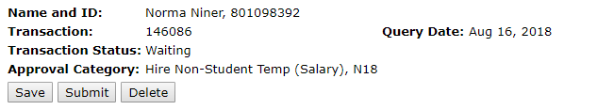
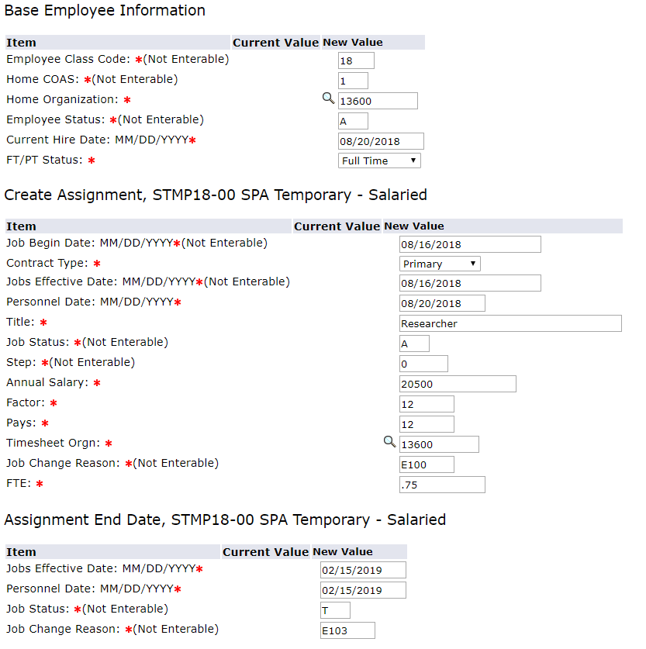
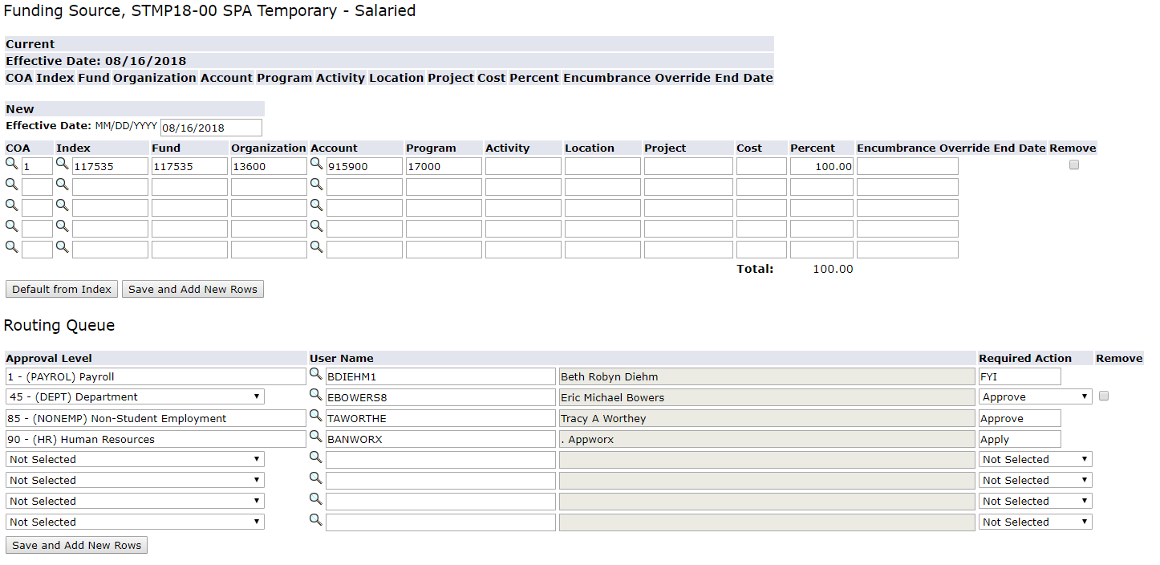
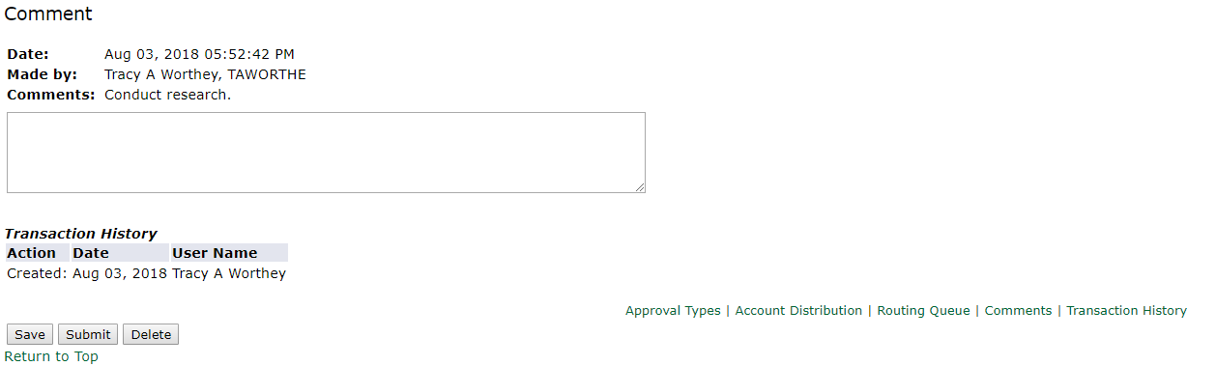

Things to know

This is what you may see when submitting your EPAF.
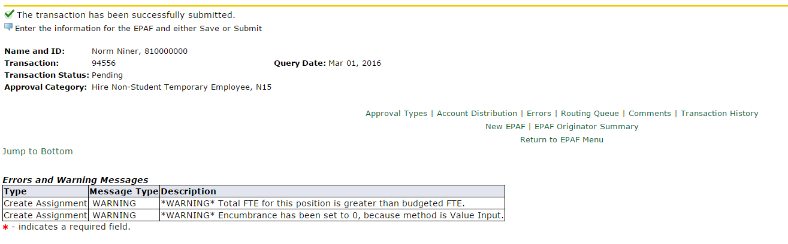
The status is pending until approved by all approvers, including HR. You can ignore warnings, but not errors.

Checking the status of your EPAF
Click on EPAF Originator Summary to see the EPAFs that you have submitted for approval. 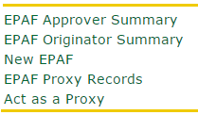
Click on the History tab to show the status of the EPAF. Under ‘Transaction Status’, to see where your EPAF is in the process.

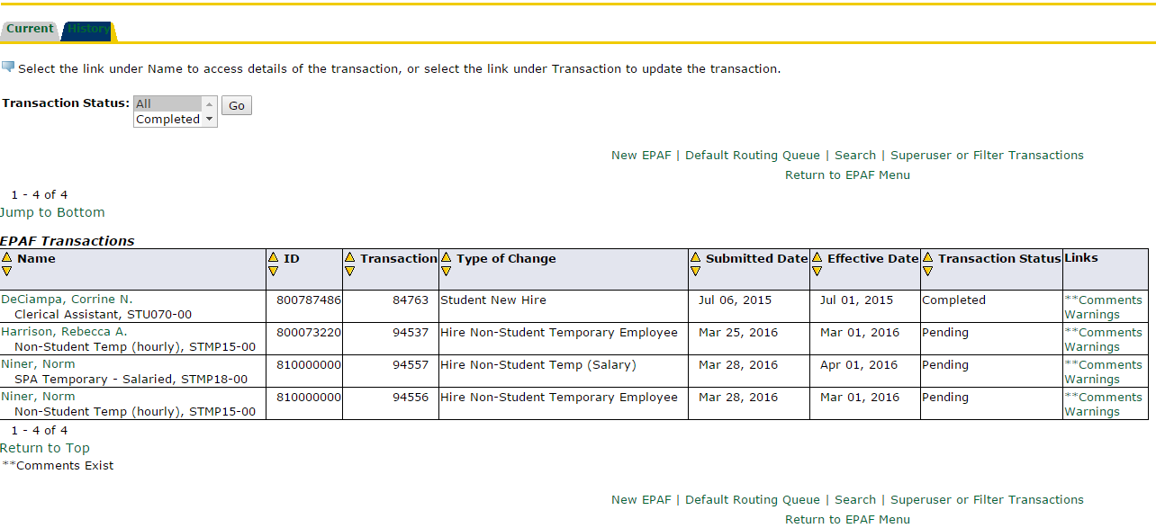
Transaction Status Meanings
Waiting – Saved but not submitted
Pending – Under review by approvers
Returned for Corrections – Sent back to Initiator to fix a problem
Disapproved – Not approved by Approvers or HR
Completed – Approved by HR
Approved – Applied to Banner

Return for corrections
As you will see this EPAF was returned for corrections. By clicking on the EPAF originator Summary, it is listed under current history.
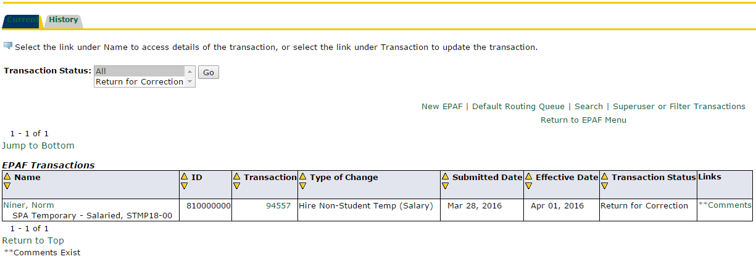

Click on Comments, under the Links box to see the reason(s) for the returned EPAF.
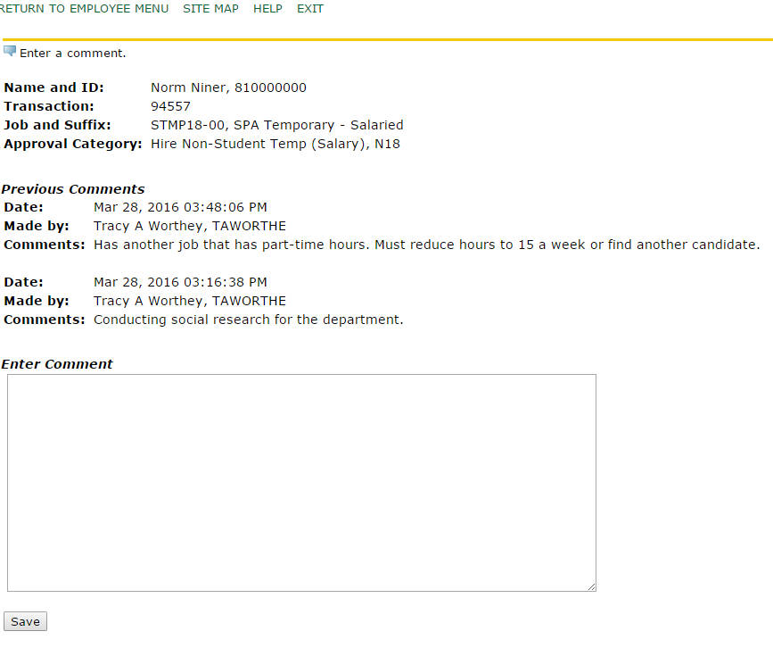
If the reason for submitting is fixable, add a comment and save. Go back to the current tab and click on the employee’s name. Click Update to make the changes.

If you are unable to fix the requested changes, you can ‘Void’ the EPAF at this point. You will then need to start the process over to submit a new one.
Once your changes are made, click Save, then Submit.

