NinerTalent
SHRA
Initiator
Applicant Tracking
User Guide

Updated March 14, 2023

Table of Contents
Overview 3
Introduction 3
Process Overview 3
Logging In 3
Locating the Applicant Tracking System Module 4
Changing your User Group 4
How to Post an SHRA Position 5
Introduction 5
Steps to Create a Posting 5
Entering the Posting Information 8
Routing the posting 11
Reviewing the Applicant Pool 12
Introduction 12
How to View a Single Applicant 12
How to View Multiple Applicants at One Time 13
Interview Resources 14
Changing Applicant Statuses 15

Introduction 15
Status Options 15
Changing a Single Applicant Status 15
Changing Multiple Applicant Statuses at Once 16
Creating an SHRA Hiring Proposal 18
Introduction 18
How to start a Hiring Proposal 18
Entering Information on the Hiring Proposal Tabs 19
Routing the Hiring Proposal 21
Making an offer to the candidate 22
Appendices 24
Appendix A: Tabs and Fields within the Posting 25
Appendix B: Tabs and Fields within the Hiring Proposal 27
Appendix C: What to do if you have trouble logging into NinerTalent 28
Appendix D: Contact Information & Additional Resources 30

Overview

Introduction

The Applicant Tracking System module in NinerTalent is where positions are posted, applications are gathered, and candidate selection is made. This module has a blue header, and will be the default module if you have not updated your preferences. The Applicant Tracking System module is used to:

- Post SHRA position vacancies
- Review SHRA applicants
- Create SHRA Hiring Proposals

Process Overview

All postings are created from a Position Description, so before you begin, please ensure the position description is up to date.

Logging In

Go to: https://jobs.charlotte.edu/hr
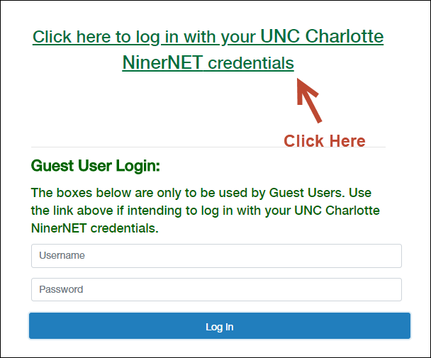
Locating the Applicant Tracking System Module

If you have not updated your settings, NinerTalent will default to the Applicant Tracking System module and Employee user group when you log-in.

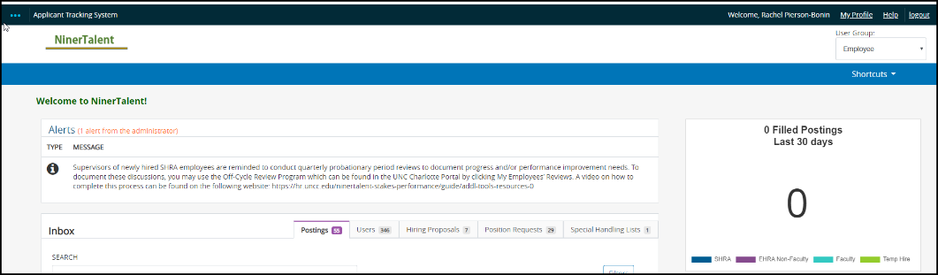

If you have made your default setting to a different module, you will need to go to the top left corner and click the three blue dots to change modules.

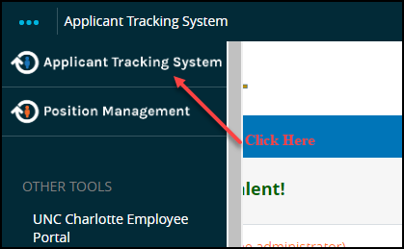

Changing your User Group

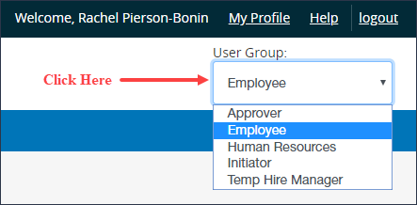

How to Post an SHRA Position
Introduction
You would create an SHRA Posting when:

- You have a vacant position; or
- An employee has given notice and you need to advertise the vacancy.

Ensure you are in the Applicant Tracking System module and logged in as an Initiator to post a vacancy. Click here for instructions on changing modules and changing your current group.

Steps to Create a Posting

- Change your Current Group to Initiator.

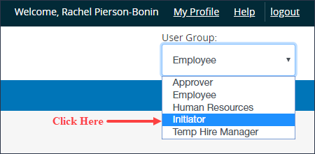

- To create a new SHRA posting, click the Postings tab and select SHRA.

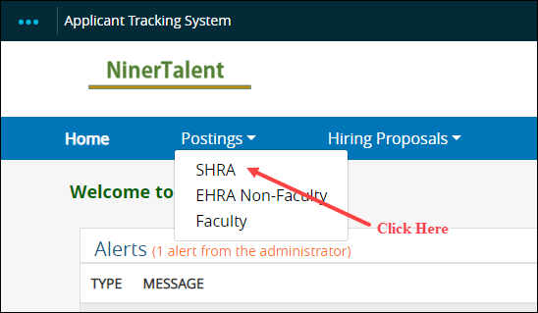

Once on this page, click the orange button labeled Create New Posting.

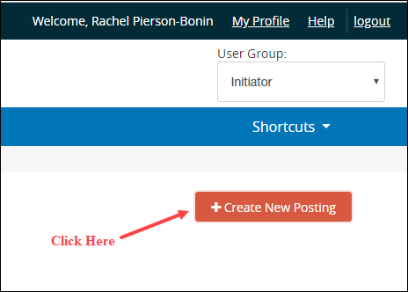

- A dialogue box will open and you will select the Create from Position Description link. You will never create a new posting from a Position Type or Classification. These options are used for other position types, not SHRA. You would only Create from a Posting if you had recently posted the identical position and need to re-post. This is only an option if nothing is being changed from the recent posting.

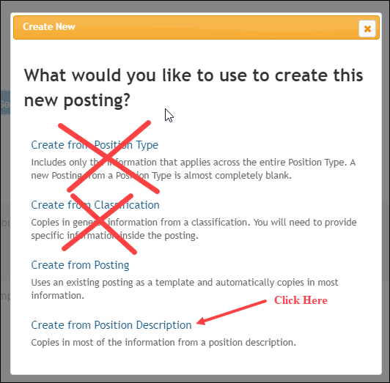

- Once you click the Create from Position Description link, a list of positions that you have Initiator access to will be displayed.

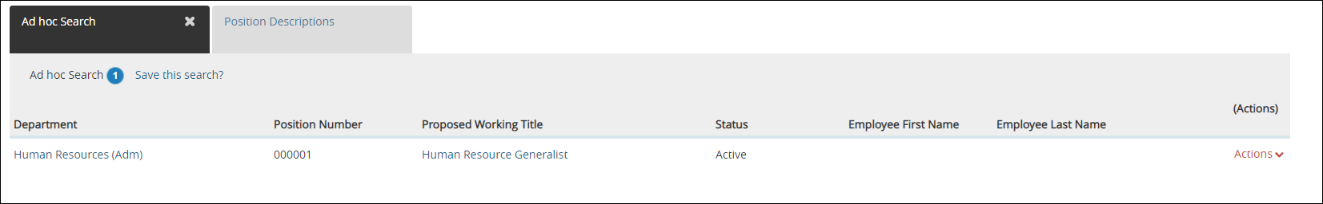

- Select the position you want to post by clicking on the Actions menu, and then selecting Create From.

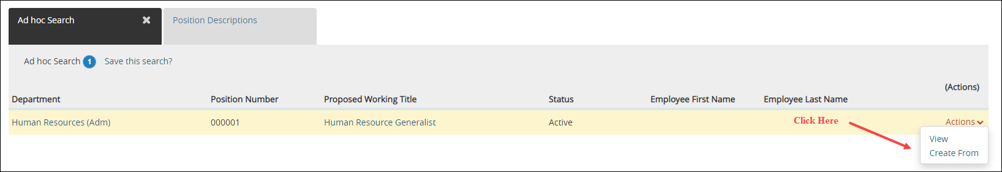

- The Working Title, Division, Department, and Work Unit will populate from the Position Description. Online applications are required, so keep the box accept online applications checked to allow applicants to apply online. Click the orange button labeled Create New Posting.

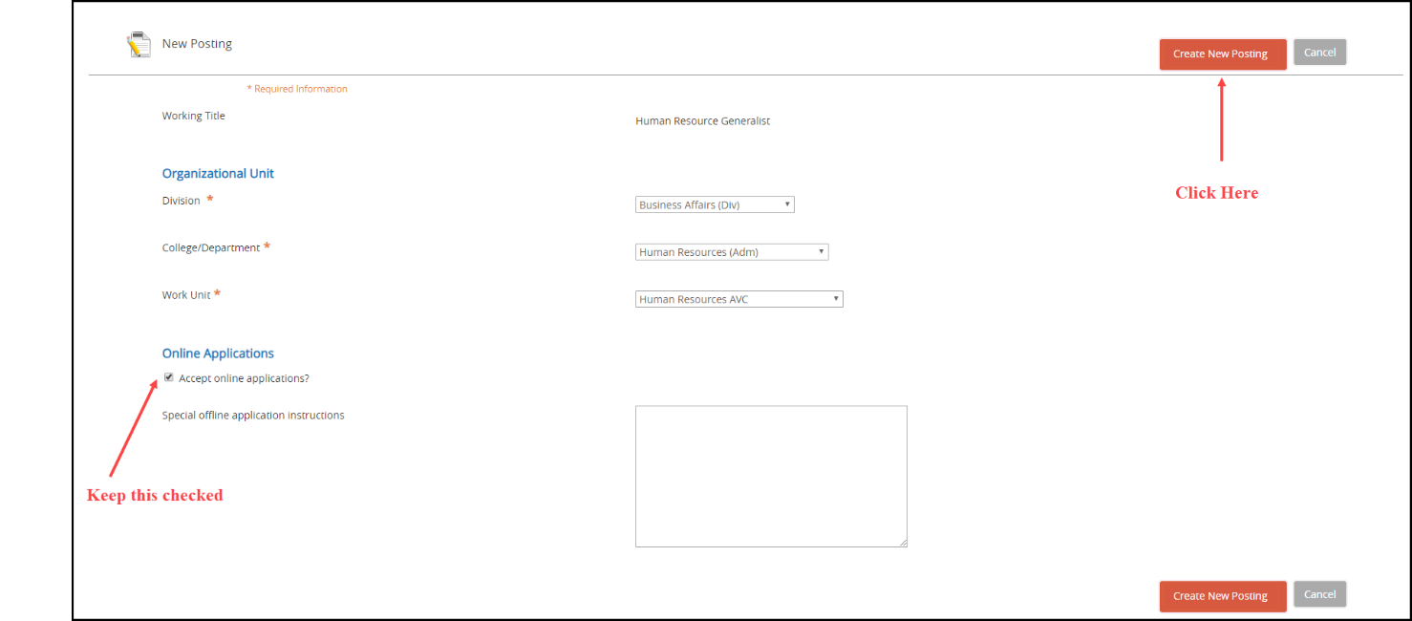

Entering the Posting Information

The posting will open to the General Information tab, and you can begin reviewing and adding the posting information. You should have very few fields to enter/edit on the posting because the information will pull from the position description. Any edits made to the posting will NOT copy back to the position description. Work through each tab on the posting and complete all necessary fields.

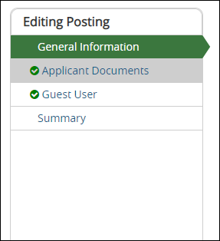

General Information tab:

Pay close attention to the following fields when editing the posting:
- Vacancy Open To – this is where you will indicate if you want the posting to be open to all applicants, or only UNC Charlotte Employees. If you select UNC Charlotte Employees Only, please remember only UNC Charlotte permanent SHRA and/or EHRA employees are considered.
- Other Initiator with Access – Those listed in this field will have access to the edit the posting, review applicants, and transition applicants in the workflow. Only those listed in this field will received the NinerTalent automated emails as the posting moves through the various workflows; i.e. posted, referred to hiring department, etc. Even if you created the posting, you will need to enter your name in this field in order to receive email notifications.
- Funding Constraint – if department has a funding constraint, with funds less than market reference rate, please enter that number in the funding constraint field.
- Job-Selection Criteria – indicates the desired education, experience, knowledge, skills, and abilities of the selected candidate. Basically, the same criteria as in your preferred qualities section. This field will transfer to the hiring proposal.
- Departmental Contact – the field is associated with the departmental contact person are all internal view only, they are not viewable to applicants. This allows Human Resources to contact the department with questions about the posting.
- Contact Information – this field is viewable to applicants, and not recommended for SHRA postings.
- Do you want to advertise externally – Human Resources will coordinate with Graystone Advertising Group or other job board sites if you want to advertise externally. Please enter where you would like the advertisement to be placed and the fund number. A representative from Human Resources will contact you with a quote for your approval.
- Separating employee information – if this is not a newly created position, please enter all information regarding the separating employee. Position updates/modifications are not considered a ‘new position’.

For more detailed explanation of posting fields please see Appendix A
Applicant Documents Tab:

All documents will default to Not Used. You will select the documents to be required, and what documents are optional in the posting. Depending on the position, we recommend to select Resume/Curriculum Vitae and Cover Letter as required.

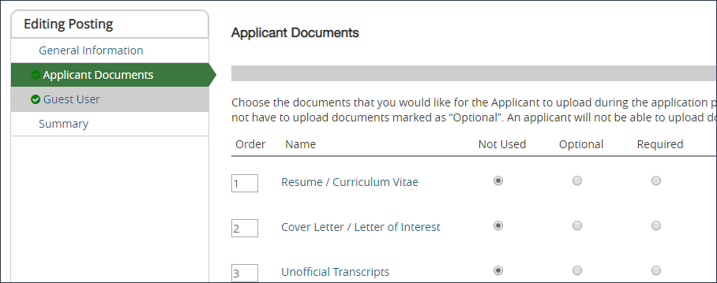

Guest User Tab:

The Guest User tab enables you to grant access to specific people so they may view the applicants only.

Click the blue Create Guest User Account button if you want to use this feature.

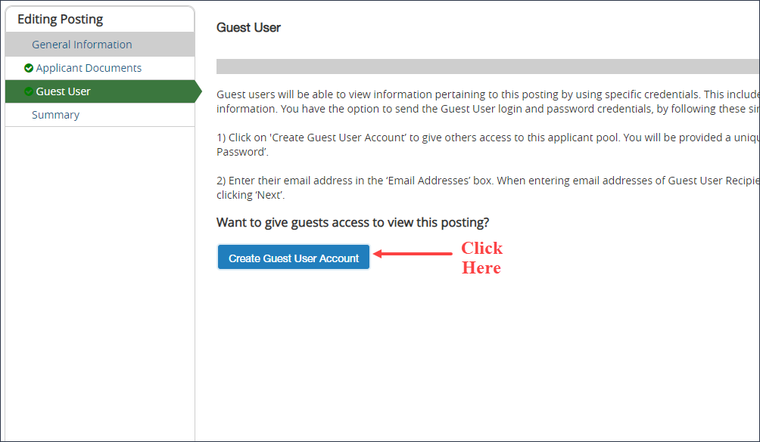

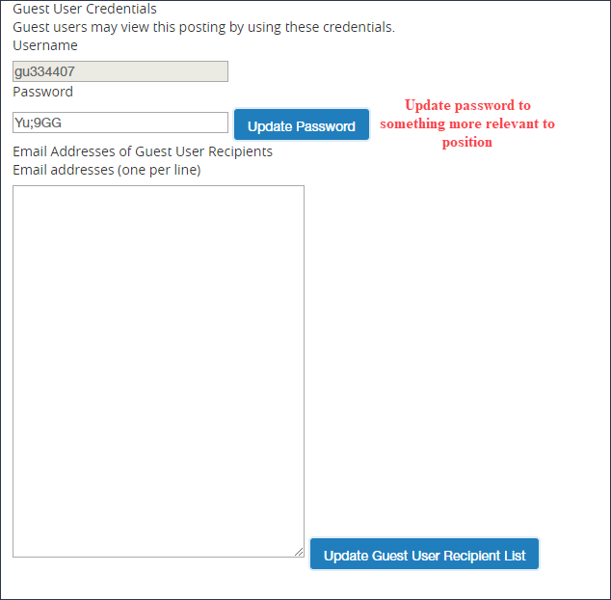

The Guest User does not have the ability to edit or route the posting. Each posting has a unique Guest User account, and you have the option to change the password. Enter the email address for each person you want to receive the Guest User email that contains the username and password for the assigned posting, then click Update Guest User Recipient List. Please remember to enter each email address on one line. The Guest User credentials will only work when the posting has been moved to the status of “Referred to Hiring Department.”

Summary Tab:

On this tab you will review all the posting information to ensure it is accurate. You can also can see how the posting looks to the applicant and add the posting to your watch list.

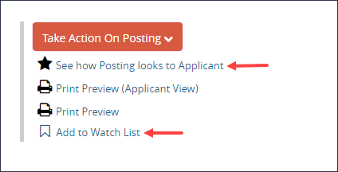

When you have reviewed the posting information and are satisfied with what has been entered, you are ready to route the posting.

Routing the posting

Once the posting information has been entered and you are satisfied with the information, you will route the posting to an additional Initiator, Approver, or directly to HR. It is recommended you send to another person in your department before sending to HR. In order to do this, you will click the orange button labeled Take Action on Posting. You can also Cancel the action.

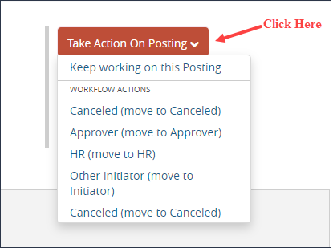

When you select Other Initiator or Approver, you will be prompted to select a specific person from a dropdown menu. When routing the posting, you have the option to enter comments. Please note that any comments entered become a permanent part of the posting history. They will also show up in the email notification sent to the selected Approver/Initiator.

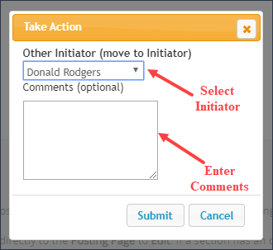

NOTE: If a person you wish to send the posting to does not appear in the drop-down menu, this individual does not have initiator or approver access.

Once the posting is routed to Human Resources, your Employment Consultant will review the posting and reach out to the departmental contact if there are any questions.

After completing all of the required HR actions, the Employment Consultant will move the posting to Posted or Approve for Later Posting.

Reviewing the Applicant Pool
Introduction

This segment of the guide describes the procedures to view the applications after the posting has closed. An Employment Consultant will screened the pool, and the most qualified applicants are referred to the department. This segment of the manual also describes how to change the Applicants’ statuses throughout the selection process, as needed.

Ensure you are in the Applicant Tracking System module and logged in as an Initiator to review applicants. Please note, only the Initiator can change the applicants’ status. Click here for instructions on changing modules and changing your current group.

How to View a Single Applicant

- Go to the Postings tab and select SHRA.

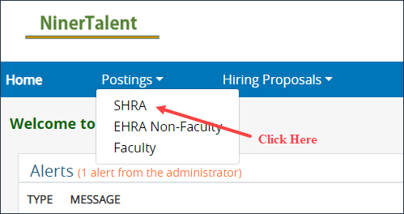

- Your active posting will be displayed. Click the Actions menu on the posting you wish to view applicants for and select View Applicants.

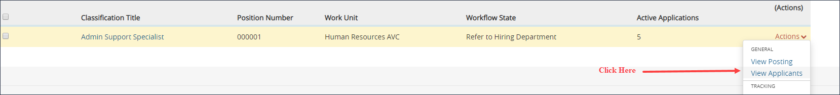

Or, you can select View Posting, then click on the Applicants tab.

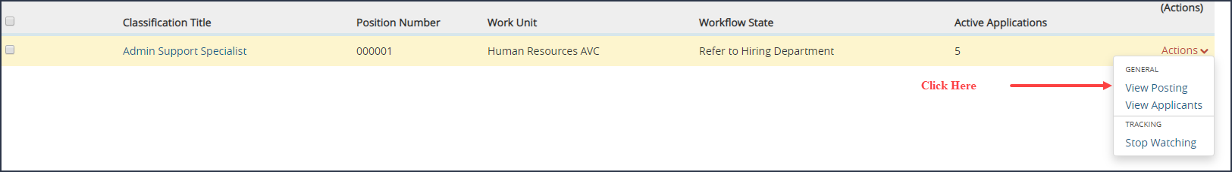

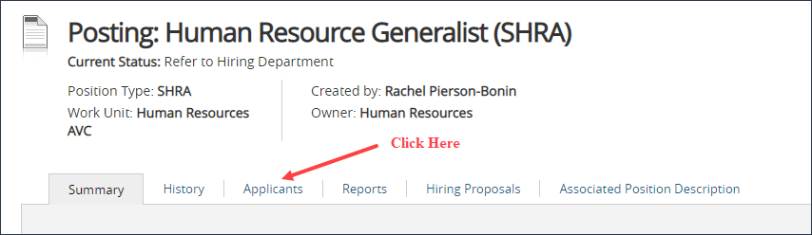

- The list of referred applicants will be viewable. To view a specific applicant, click the Actions menu next to that application and select view application. You will have to scroll to the bottom of the applicant’s information to view the different documents submitted.

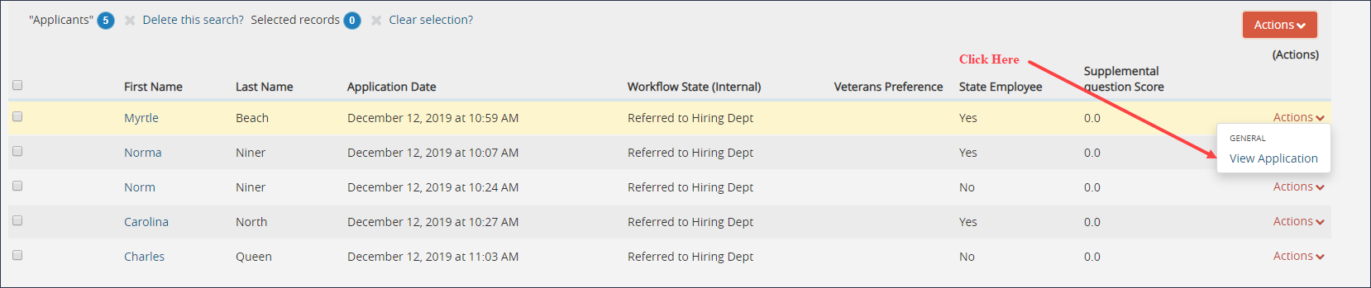

You can click on the Resume, or you can click Generate at the bottom of the screen to view a combined document.

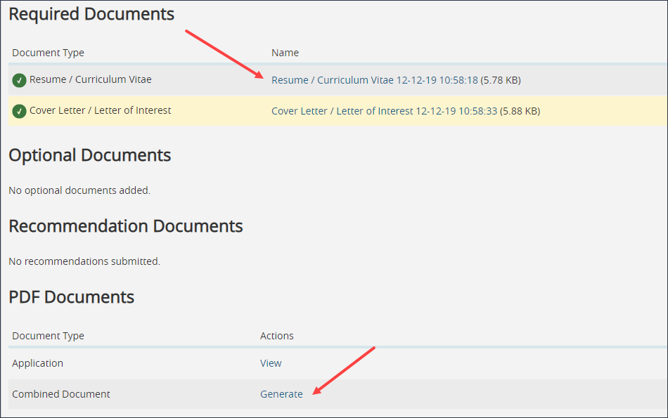

How to View Multiple Applicants at One Time

- To view multiple applications at once, select the checkboxes next to the applicant’s name and click the orange Actions menu. Select Download Applications as PDF.

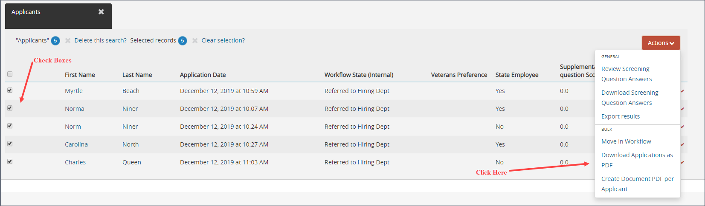

A dialogue box will appear that will ask which documents you want to use.

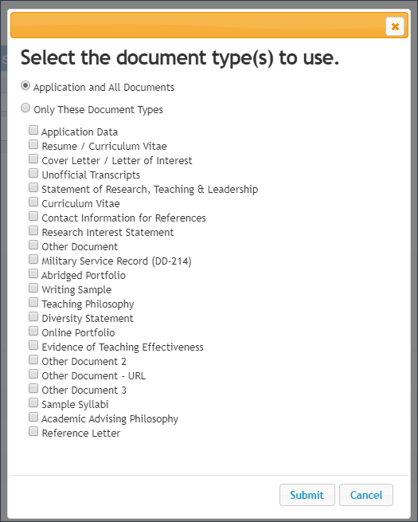
If you are only interested in viewing the resumes, you can select that box. The more document types you include, the larger the file and the longer it will take to download. When you click Submit you will get a message that a file is generating. This can take a few minutes if you selected a large number of applicants and document types. Once the file finishes generating, it will open automatically. Please note it does not open in a separate window.

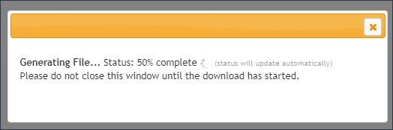

There are two easy options to view the applicant documents and the applicant list in NinerTalent at the same time:

  - Open a second window and reopen NinerTalent, OR

  - Save the PDF download and open it in Adobe. Then click the back button on your web browser to get back to the applicant list.

Interview Resources

Please click here for Guidelines For Interviewing Job Applicants.

Please contact your Employment Consultant for Competency Based Interview Questions. Also, please send your Employment Consultant the list of interview questions you are going to ask prior to beginning interviews.

Changing Applicant Statuses

Introduction

It is a best practice to change the applicant statuses at the end of your interviews, but please take notes as you review each application. This helps you move through the process easier and keeps your non-selection rationale relevant.

You can change applicant statuses individually, or in bulk.

Status Options

The tables below describe each of the status options for referred SHRA applicants.

 | When to Use
Referred not Interviewed | You determined the applicant is not as qualified as those you would like to interview, based on the education and experience listed in the application materials.
Interviewed, not selected | You have interviewed the applicant and determined they are not as qualified, based on the interview, compared to the selected candidate.
Second Choice Candidate | The applicant has many strong qualifications, but lacking essential skills compared to the selected candidate. You would consider hiring if the first-choice candidate declines.
Recommend for Hire | You have identified an applicant as the most qualified candidate and ready to begin the hiring proposal.
*Email notifications will be sent to applicants when HR has marked the posting as Filled

Changing a single applicant status

- Click on the Applicant’s first name. Once the application is open, click the orange Take Action on Job Application, and select the appropriate status option.

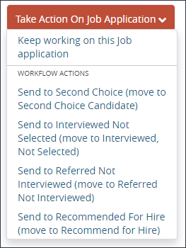

- A dialogue box will open and you will need to enter the non-selection rationale, with specific skills/experience/behavior the applicant was lacking. Once you are satisfied, you will click Submit.

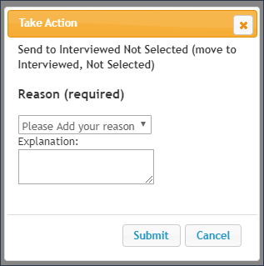

Changing multiple applicant statuses at once

- Instead of downloading the applications, you will select Move in Workflow.

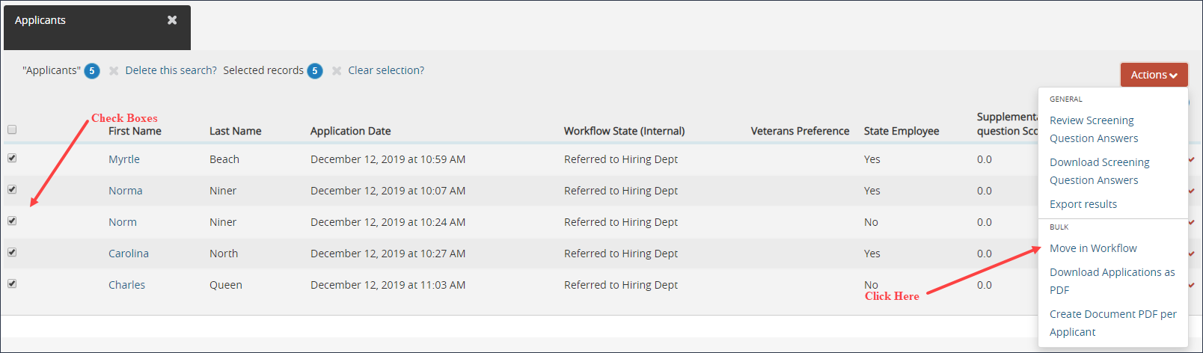

- To change all applicants to the same status, use the drop down at the top of the screen. Then a second box will appear, and you will use the drop down at the top to enter the non-selection rationale for each applicant.

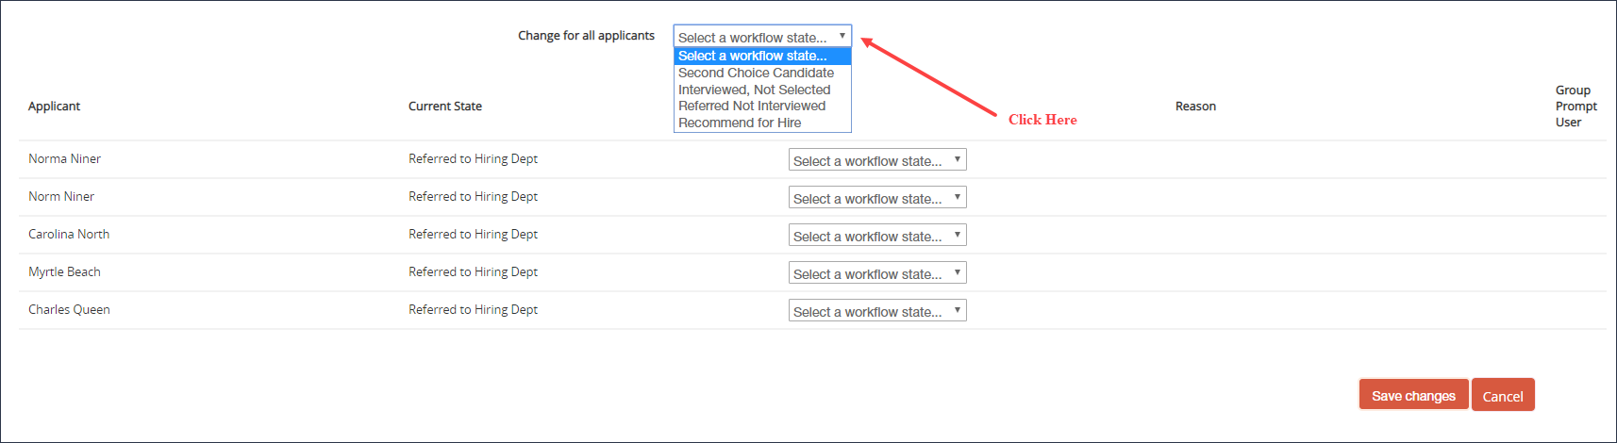

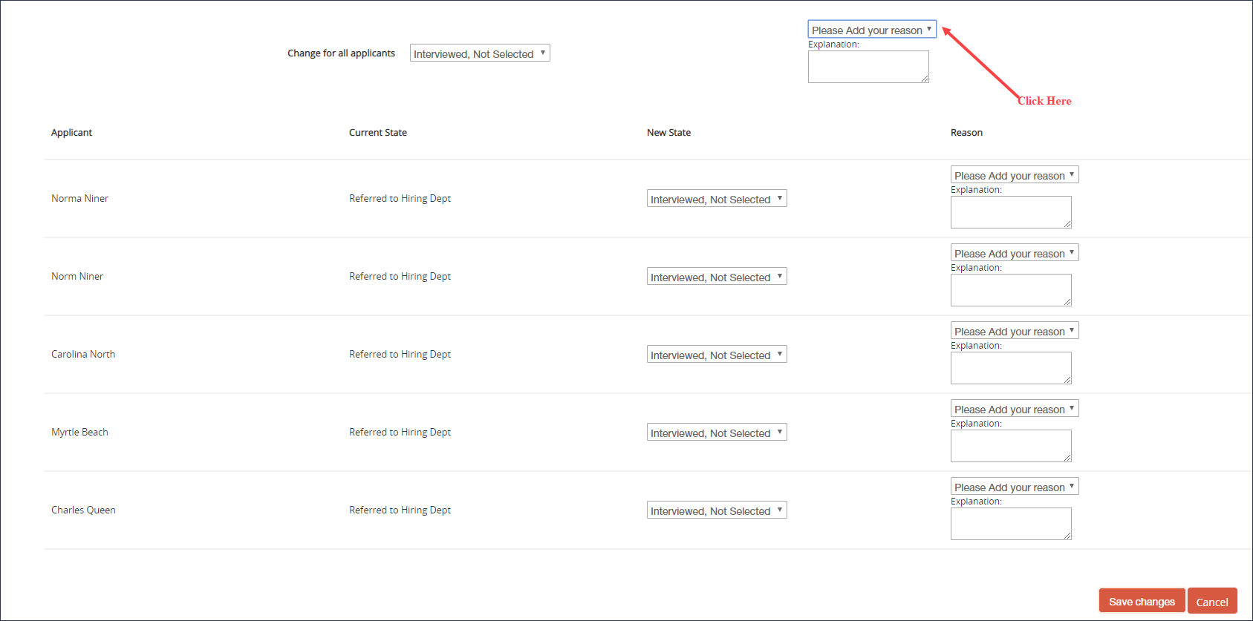

Or, you can select each applicant’s status individually by clicking the dropdown menu next to their name.

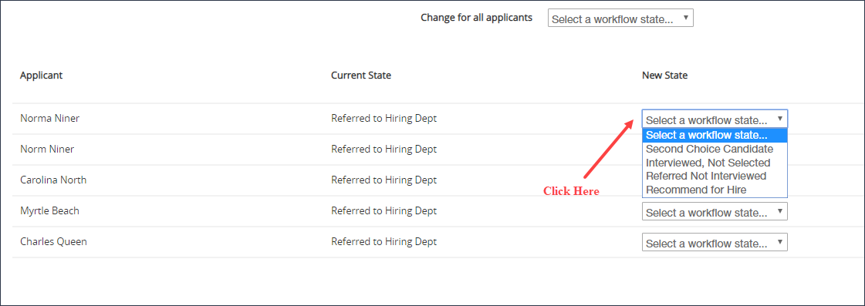

- When you are finished, click Save Changes.

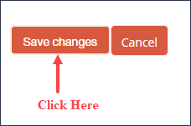

Creating a Hiring Proposal

Introduction

The hiring proposal is created to send your selected candidate to Human Resources for review and approval. This is the final step in the NinerTalent recruitment process. You should not communicate an offer with your candidate until you have approval from Human Resources.

Ensure you are in the Applicant Tracking System module and logged in as an Initiator to create the hiring proposal. Please note, only the Initiator can change the applicants’ statuses and start hiring proposal. Click here for instructions on changing modules and changing your current group.

How to Start a Hiring Proposal

- Locate the posting that you are working on by clicking on the Postings tab and selecting SHRA.

- Go to the applicants in the posting. Click here for instructions on locating your applicants.
- The only active applicant you should see is the candidate you have marked Recommend for Hire. If you have not updated your candidate statuses, please click here for instructions on changing applicant statuses. All applicant statuses must be updated in conjunction with the hiring proposal being completed.
- View the candidate’s application by either clicking on the applicant’s name, or clicking Actions and selecting View Application.

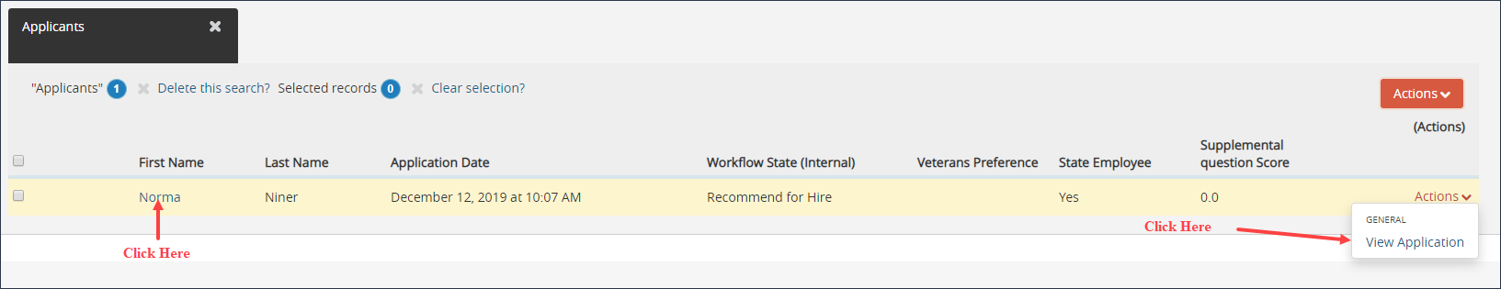

- The applicant’s information will be displayed. On the right side of the screen, select the green plus sign with a link to Start Hiring Proposal. This link will only show up if the applicant is in “Recommend for Hire” status. Click this link.

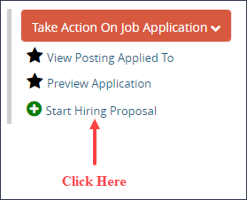

- On the next screen review the information to ensure you have the correct applicant and posting. If so, click the blue Start Hiring Proposal button.

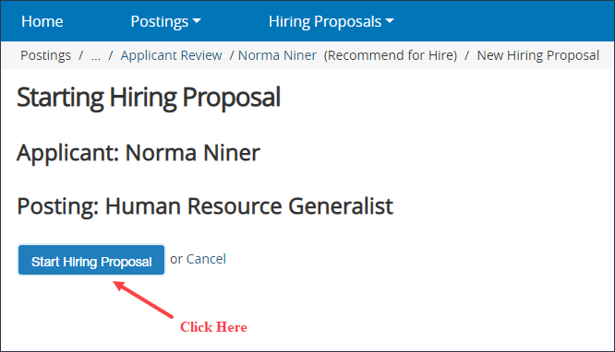

Entering Information on the Hiring Proposal Tabs

The hiring proposal tabs are displayed on the left. Go through each tab and enter the appropriate information.

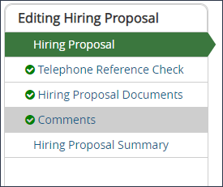

Hiring Proposal Tab:

  - The candidate information and position information will automatically populate. If the candidate has an UNC Charlotte ID #, please enter it in the open text box.
  - Other Initiator with Access: If you want a different Initiator to complete the hiring proposal, add their name here. You still have to complete the required fields before routing it to them.
  - If you are filling multiple positions from this posting, be sure to enter the position number that you want this candidate to fill. If you did not put a note in the posting indicating you were filling more than one position from the posting, you cannot hire multiple applicants.
  - Enter the five-digit Banner org number for the department the candidate will be working in, not the org number associated with the position funding.
  - Candidate Selection Rationale: This field should be a detailed explanation (one to two paragraphs) of what education, experience, and skills make the candidate the best qualified for the position, based on the Job-Selection Criteria listed on the posting.
  - Select the appropriate competency level of the candidate, which should match the position. If it does not the reason should be documented under the Salary Justification box.
  - Proposed Annual Salary: This is the salary you are recommending within the salary range listed on the posting.
  - Salary Justification: This should be an explanation of the salary you are proposing, if the salary is higher or lower than the range that HR approved.
Telephone Reference Check Tab:
This tab is used to enter the telephone reference checks that you obtained. Two telephone reference checks are required for all external candidates (remember that student and temporary staff are considered external candidates). If the candidate is internal and does not work directly for you, one telephone reference check is required (preferably from a current supervisor). You will add a separate entry for each reference check. To add an entry, click the blue Add Telephone Reference Check Entry button.

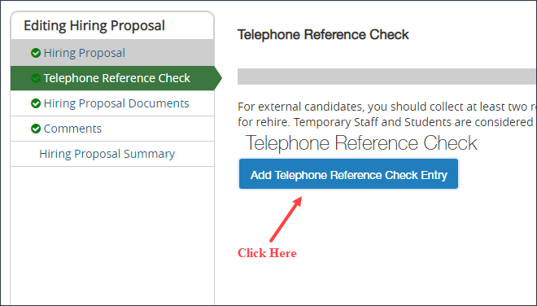

This will open the information that HR would like you to obtain about the applicant. Please reference the Telephone Reference Check form on the Human Resources website to record your notes to transfer to the hiring proposal.

You can add as many entries as needed. Please remember that the best references come from previous supervisors and/or employers.
Hiring Proposal Documents Tab:

In this tab you will upload the interview questions asked of each applicant. Note: we do not need the applicant’s answers to the questions, only the questions. You will also upload the Work Sample instructions you gave the applicants if you did one.

Comments Tab:

This tab allows you to add any comments regarding the hiring proposal.

Hiring Proposal Summary Tab:

Review the hiring proposal information for accuracy and completeness. When you are satisfied with the information entered, you are ready to route the hiring proposal.

Routing the Hiring Proposal

Once you have entered all the hiring proposal information you will route the hiring proposal to the next step in the process.

- Click the orange button labeled Take Action on Hiring Proposal from the Hiring Proposal Summary screen. You will have the option to send to another Initiator or Approver. If you do not need to route your hiring proposal to an additional person in your department, you can route to HR Employment. HR highly recommends that hiring proposal are routed to either your supervisor or business officer for approval.

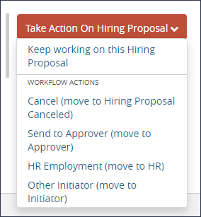

- A dialogue box will open up, prompting you to select a specific person to route the hiring proposal to Other Initiator or Approver. When routing the hiring proposal, you have the option to enter comments. Please note that any comments entered become a permanent part of the hiring proposal history. They will also show up in the e-mail notification that goes to the selected Approver/Other Initiator.

Making an offer to the candidate

A number of actions occur when Human Resources receives the hiring proposal:

- Human Resources reviews the applicant pool, ensuring all applicant statuses have been changed, an appropriate number of interviews were conducted, and non-selection rationale is related to the job.
- Human Resources reviews the hiring proposal to ensure it is complete and the information provided justifies the recommendation for hire. Salary justification and determination is also reviewed at this time.
- If the candidate is internal to UNC Charlotte Human Resources will verify salary and ensure all state policies are being followed.
- The Criminal Background check process is initiated.

Human Resources will contact the Initiator directly if there are questions regarding the hiring proposal or process.

When Human Resources has received the Criminal Background Check results and has approved the recommendation for hire, they will route the hiring proposal back to the Initiator as Approved for Offer. The HR approved salary is provided in the hiring proposal.

At this time, the Initiator can move forward with making an offer to the candidate. Once the candidate accepts the offer, the Initiator will need to enter the candidate’s salary and start date.

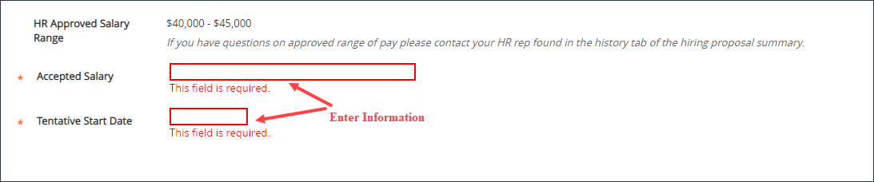

Route the hiring proposal back to Human Resources as Offer Accepted – Notify HR to be processed.

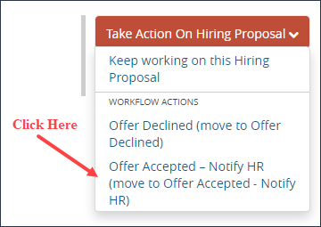
*Please let your HR Consultant know if your selected candidate declines the offer

Human Resources will change the selected candidate’s status to Approved for Hire and mark the posting Filled.

Appendices

Appendix A: Tabs and Fields within the posting | Describes each tab and field within the Posting
Appendix B: Tabs and Fields within  the Hiring Proposal | Describes each tab and field within the Hiring  Proposal
Appendix C: What to do if you have  trouble logging into NinerTalent | Troubleshooting if you are having problems logging  into the system
Appendix D: Contact Information and Additional Resources

Appendix A: Tabs and Fields within Posting

Field Label | Type of Field | Explanation
Vacancy Open To | Drop-down menu | Department’s preference on posting for all candidates, or just internal UNC Charlotte permanent employees.
Employment Type | Fixed | Pulls in from Position Description.
Hours per week | Fixed | Pulls in from Position Description.
Months per year | Fixed | Pulls in from Position Description.
Other initiator with access | Fixed/Text | Pulls in from Position Description, but can add other initiators at time of posting.
Career Band/Role | Fixed | Pulls in from Position Description.
Competency Level | Fixed | Pulls in from Position Description.
NC Salary Grade Equivalency | Fixed | Pulls in from Position Description.
Classification Title | Fixed | Pulls in from Position Description.
Working Title | Fixed | Pulls in from Position Description.
Salary Range | Not shown on posting | HR Consultant will enter.
Does this position have a funding constraint | Drop-down menu | Enter “yes” if salary constraint on position is less than market.
If funding constraint | Text Box | Enter salary amount
FLSA Status | Fixed | Pulls in from Position Description.
Division | Drop-down | Pulls in from Position Description, but shouldn’t need to update.
Department | Drop-down | Pulls in from Position Description, but shouldn’t need to update.
Work Unit | Fixed | Pulls in from Position Description.
Work Schedule | Text Box | Pulls in from Position Description. If not correct on posting, need to update on Position Description.
Primary Purpose of Position | Fixed | Pulls in from Position Description.
Minimum Education/Experience | Fixed | Pulls in from Position Description. HR consultant will adjust based on Competency Level
Essential Duties Summary | Text Box | Pulls in from Position Description, but can edit. Primary duties of the position that applicants will do on a regular basis. You need to be thorough and identify the specific duties of this position.
Other Work Responsibilities | Text Box | Pulls in from Position Description,  but can be edited. Duties that are  important, but done less frequently.
Preferred Experience | Text Box | Pulls in from Position Description, but can edit. Description of what your ideal candidate will have in the way of education, experience, knowledge, skills, and abilities. Must be more than the minimum requirements. The more detail here the better.
Job Selection | Text Box | Indicates the desired education, experience, knowledge, skills, and abilities of the selected candidate. Basically, the same criteria as in your preferred qualities section.
Work Location | Text Box | Pulls in from Position Description.
Proposed Hire Date | Text Box | Date you hope to have the position filled by. Realistically at least a month from posting.
Departmental Contact Name | Text Box | Who should HR contact with questions regarding the posting. Not viewable to applicants
Departmental Contact Email | Text Box | Email address. Not viewable to applicants.
Department Contact Extension | Text Box | Phone number. Not viewable to applicants.
Contact Information | Text Box | Do not enter a name. This field is viewable to applicants.
Special Instructions to Applicants | Text Box | Used by HR and the departments to convey vital information to the applicant. i.e. “Applicants must attach a portfolio with their application.
Advertising | Drop-down, Text Boxes | Used to indicate the advertising locations requested by the department. You must provide the fund number.
HR Consultation Requested | Drop-down | Indicate if the department wants to discuss the posting with Human Resources before the position is officially posted on our website.
Quick link | System created | Link that you are able to send applicants when the posting is Posted.
Suggest Questions for Applicants | Text Box | Used by HR Consultant for screening and hiring department to ask candidates supplemental questions on the application. Questions should be skilled or experience based.
Is this a newly created position? | Drop-down | If no, complete following fields. If yes, move to next tab.
Separating employee | Text Box | Complete employees’ full name, UNC Charlotte ID, and date they are separating. Indicate if an exit interview has been scheduled with Benefits.
In NinerTalent * with red box around the field indicates a required field and must be completed

Appendix B: Tabs and Fields within Hiring Proposal

Candidate Information

Field Label | Type of Field | Explanation
First Name | Fixed | What applicant entered on  application.
Last Name | Fixed | What applicant entered on application.
UNC Charlotte ID # (if  applicable) | Text Box | Check Banner, enter if known.

Position Information

Field Label | Type of Field | Explanation
Career Band/Role | Fixed | Pulls in from Position Description.
HR Approved Overall Competency Level | Fixed | Pulls in from Position Description.
Position Number | Fixed | Pulls in from Position Description.

Hiring Proposal Information

Field Label | Type of Field | Explanation
Job-Selection Criteria | Fixed | Pulls in from Posting
Candidate Selection Rationale | Text Area | A detailed explanation of how your selected candidate meets the selection criteria and is the best qualified for the position.
Proposed Annual Salary | Text Box | Enter the salary amount you are requesting if outside of the salary market ranges.
Salary Justification | Text Area | If salary requested
HR Approved Salary | Fixed | Will be entered by HR.
In NinerTalent * with red box around the field indicates a required field and must be completed

Appendix C: What to do if you have trouble logging into NinerTalent

Go to http://jobs.charlotte.edu/hr.

The Username and Password on this page are for Guest User Accounts.

You need to click on the green link (shown below) to access NinerTalent with your NinerNET credentials.

Result: The UNC Charlotte Web Authentication page opens.
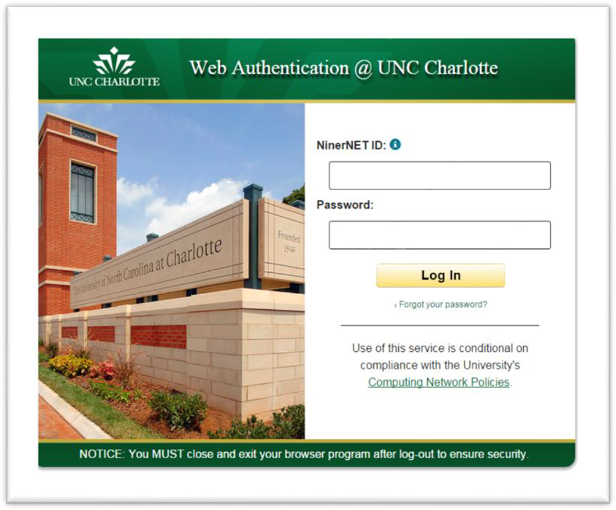

Enter your NinerNET credentials.

If you cannot log in, clear your Internet browser’s history and cache. Additionally, close all of your open browser windows and try again.

In addition, if you cannot gain access after clearing your browse history, cache, and closing all other browser windows, repeat these steps and include @uncc.edu after your NinerNET ID.

Contact NinerTalent@uncc.edu for help with login issues.

Appendix D: Contact Information & Additional Resources

Kel Dudden  kdudden@uncc.edu  7-0668 | - Academic Affairs  - University Advancement  - Chancellor’s Office
Felicia Thompkins  fthompki@uncc.edu  7-0667 | - Athletics  - Student Affairs
Heather Benson  Hbenson3@uncc.edu  7-7863 | - Business Affairs

PIM 43 – Merit-Based Recruitment and Selection Plan for Classified Staff Employees (SHRA – Subject to the State Personnel Act)

Please visit the Hiring page on the UNC Charlotte Human Resources website.

