How to Initiate a
Web Time Entry
Approver Change
EPAF
This change is for Student Temporary and Non-Student Temporary Employees Only
- Login to ‘My UNC Charlotte’ using your NinerNet credentials
- Click on Self Service Banner
- On the following page, click on the ‘Employee Tab’ at the top of the page and then click on ‘EPAF – Electronic Personnel Action Form’
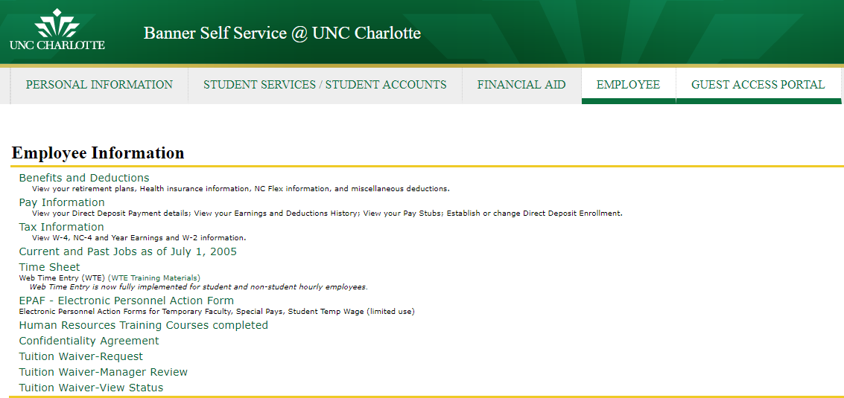

- Click on ‘New EPAF’
- Enter the ID Number of the Student or Non-Student Temporary that needs a Web Time Enter (WTE) Approver Change. If you don’t know the ID Number, click on the magnifying glass icon. It will take you to a page where you can search for it.
- Once the ID Number is ascertained and selected; in the ‘Query Date’ field enter the effective date of the WTE approver change. In the ‘Approval Category’ field, click on the drop down arrow, choose ‘WebTime Approver, WTEAPR’, and hit ‘Go’.

- Choose the position that you want to make the change to and hit ‘Go’:
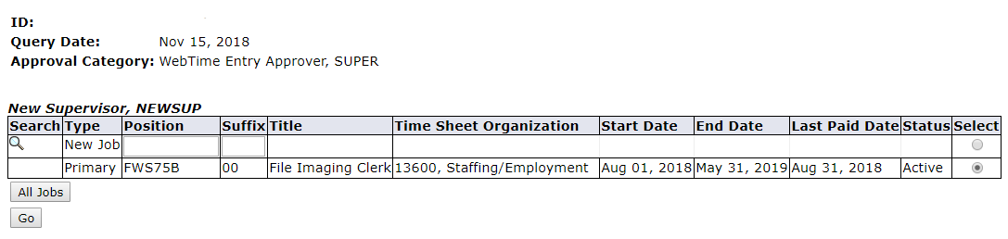
- The Jobs Effective Date will be the date the WTE Approver change needs to go into effect. In the ‘Supervisor ID’ field, enter the ID Number of the new WTE Approver. Tab down to the ‘Routing Que’ section, click on the magnifying glass and chose BANWORX. Then click on the ‘Save’ button at the bottom of the page.
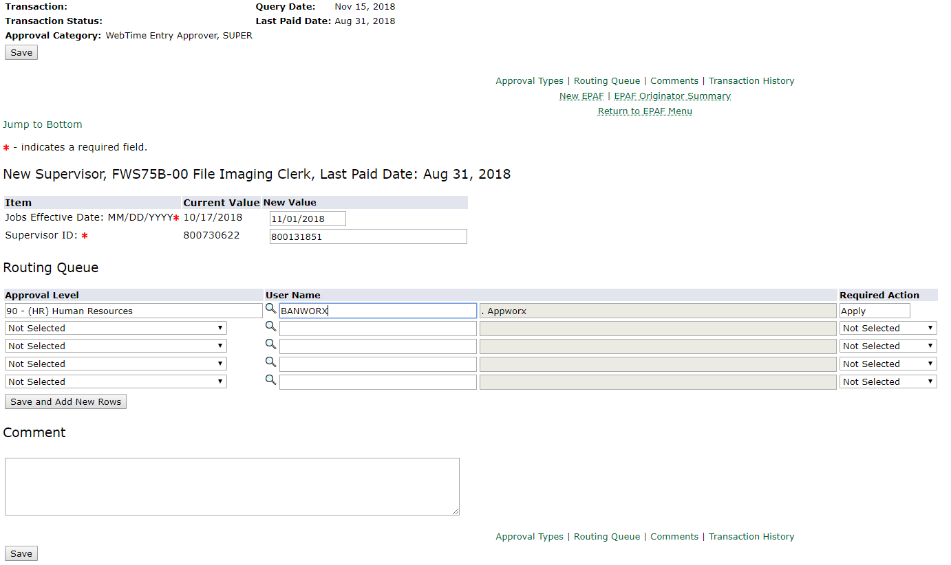

- Please, review information for accuracy. If everything is correct, hit ‘Submit’.
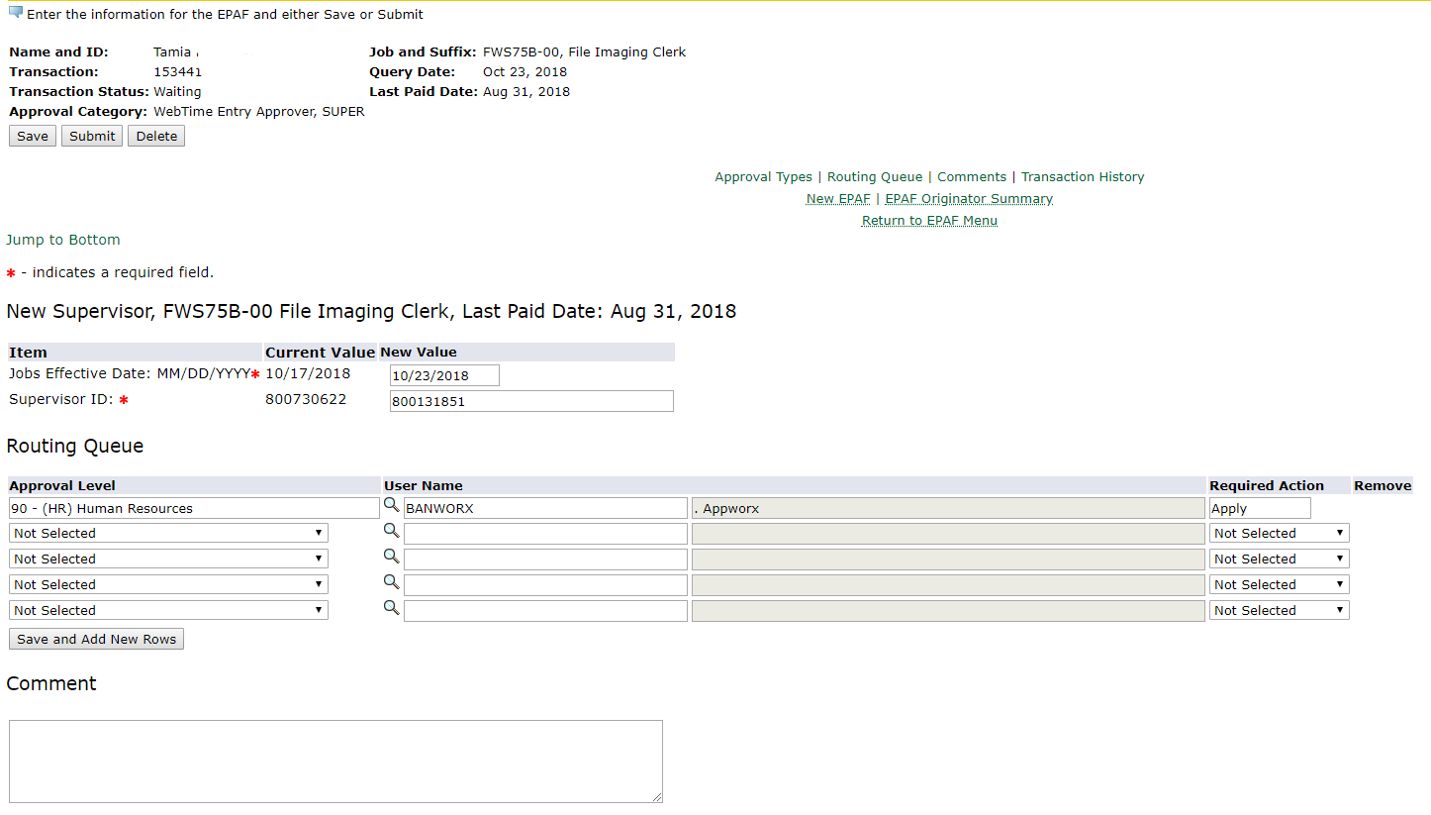

- Once you submit, the top of the EPAF will indicate that the transaction has been successfully submitted and the status is Approved.

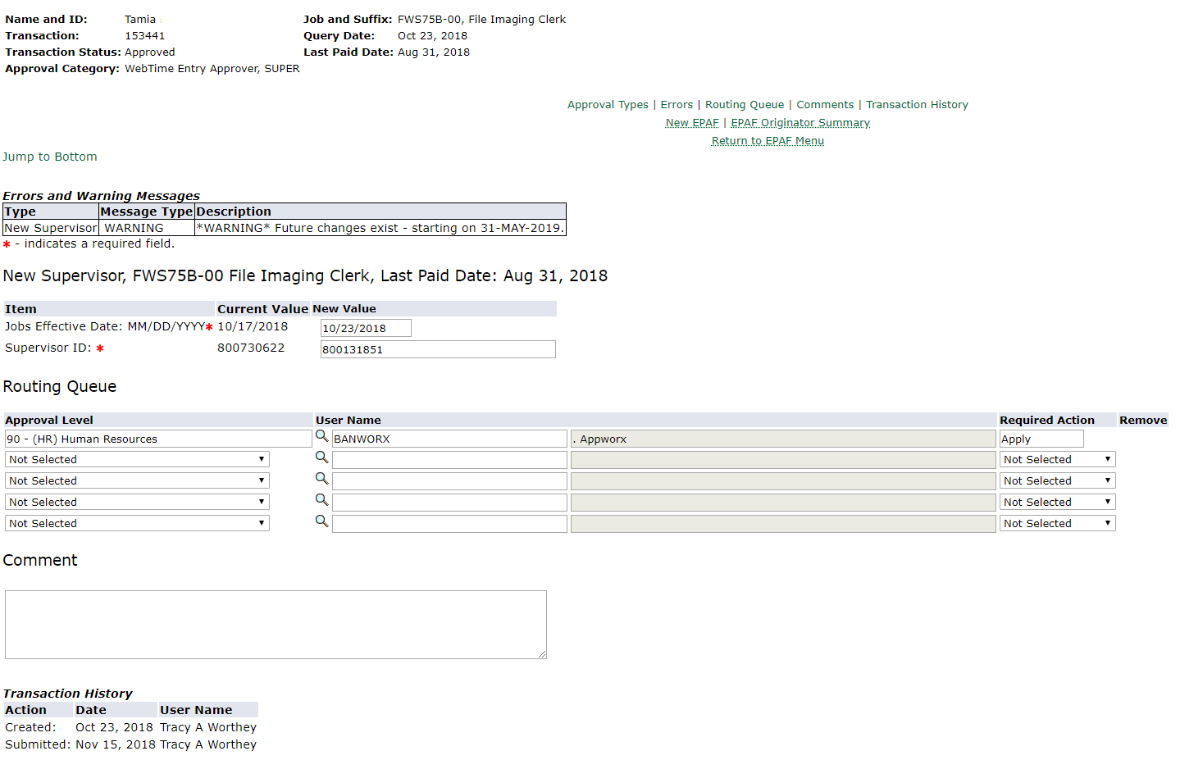
- EPAFs upload to Banner periodically throughout the day. Your EPAF change will be reflected after the next available upload.

