Hiring Student Temporary Wage using Banner EPAFs

Version 4.0 – September 2021
© UNC Charlotte Human Resources

Contents
EPAF Defined 3
Graduate Assistantships 3
Requirements for Student EPAFs 3
EPAF Access 3
Hiring Student Temporary Hourly Wage Employees 5
Creating an EPAF 5
Completing the Temporary EPAF form 7
Section 1: Employee Information 7
Section 2: Job Assignment Information 8
Section 3: Job Termination 9
Section 4: Funding Information 10
Section 5: Routing Queue 11
Section 6: Comments 12
Finishing up… 12
Who to Contact 13
Appendix 14
Checking the status of your EPAF 17
Return for corrections 18

EPAF Defined
An Electronic Personnel Action Form is a Banner Self Service form, which allows you to submit recommendations for hire to the Human Resources office. Once the form is completed and submitted, it is routed it to the appropriate approvers. After all approvers have approved the employment action, the EPAF is applied to Banner and the employee is set up for payroll.
Some advantages to using EPAFs:
- Paperless process for newly hired student hourly wage employees; this relaxes the workload for both your department, Human Resources and Payroll
- Less chance of processing errors

Graduate Assistantships
- Graduate Assistantships are processed and hired through the eGA application, found at https://ega.uncc.edu/.
- Otherwise, Graduate Students hired for a student temporary wage job would use this Banner EPAF form.

Requirements for Student EPAFs
- Student employees must be registered in the term they are working and have a valid I-9 form on file with the Human Resources department. For summer employment they can be registered for a summer session, if not, they must be registered for the coming fall semester.
- Please make sure your student employees meet these two requirements before submitting a Student EPAF and allowing them to work.

EPAF Access
To request EPAF access, please go to our website and complete the EPAF Access Request Form, found at https://hr.charlotte.edu/forms/electronic-forms.
Once the request for access is processed and approved, you will be able to login to Banner Self Service, through My UNC Charlotte, to submit EPAF transactions.
To access the EPAF menu, click on the Employee Information link or the Employee tab, as shown in Figure 1.
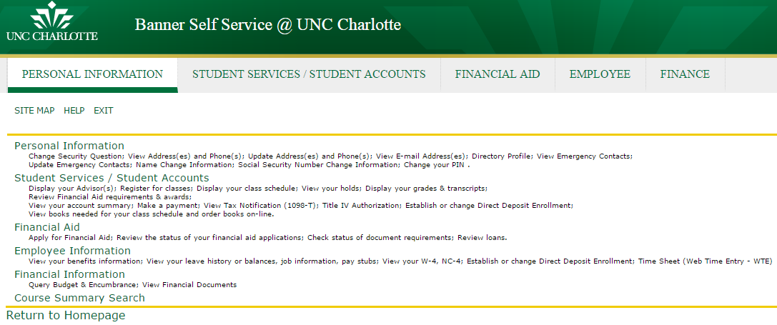
Figure 1 - Employee Information

Click on the link for EPAF – Electronic Personnel Action Form, shown in Figure 2. If you do not see the EPAF link, you do not have access to create an EPAF.
Please go to https://hr.charlotte.edu/forms/electronic-forms to request access.
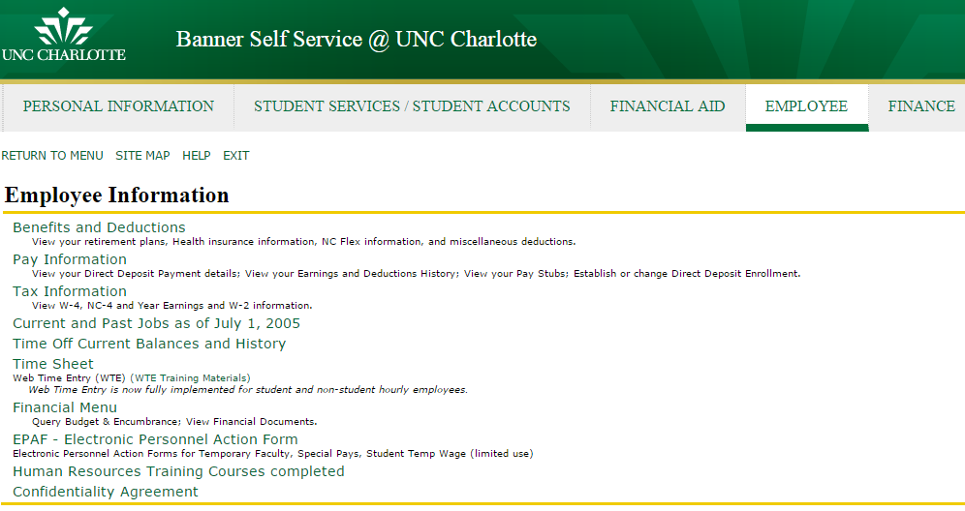
Figure 2 - EPAF Menu Item

Hiring Student Temporary Hourly Wage Employees
This guide will walk you through the process of creating an EPAF for a Student Temporary Hourly Wage employee.

Creating an EPAF
Select New EPAF (Figure 3).
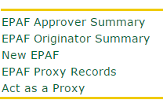
Figure 3 - New EPAF

Next, complete the form on the page (Figure 4). Input the student’s UNCC ID number, or if you do not know their ID number, click on the search icon to search by name.
The Query Date will always be the first day of the pay period, in which the employee starts work. Please download the payroll calendar to select the appropriate query date, based on the employee’s start date. Download the EPAF Submission calendar for payroll dates.
If this is a new hire, make sure you select “Student New Hire, S70N”. However, if they are a rehire then select “Student Reappointment, S70R”. Then select ‘Go’.
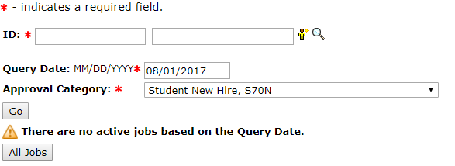
OR
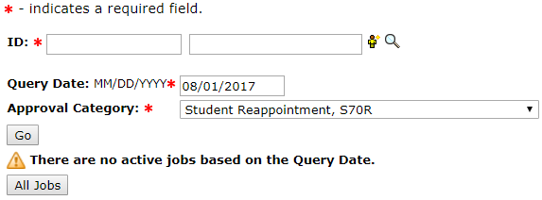
Figure 4 – Query Date
Once you have selected the student you wish to hire, you will be presented with a screen to create a new job assignment (Figure 5):
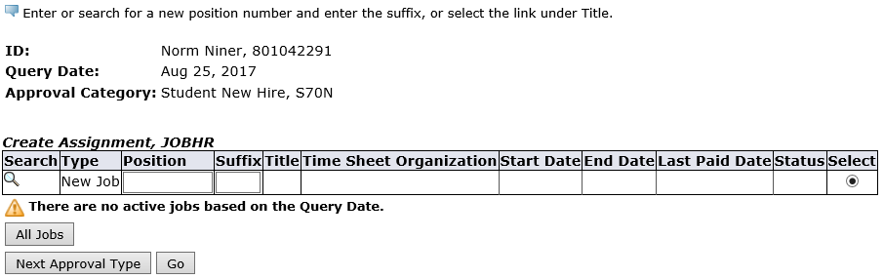
Figure 5 - Create Assignment

If this is a new hire, enter STU070 in the position field and 00 in the suffix field (Figure 6). There should not be any other jobs in the system. Click on ‘All Jobs’ to verify.
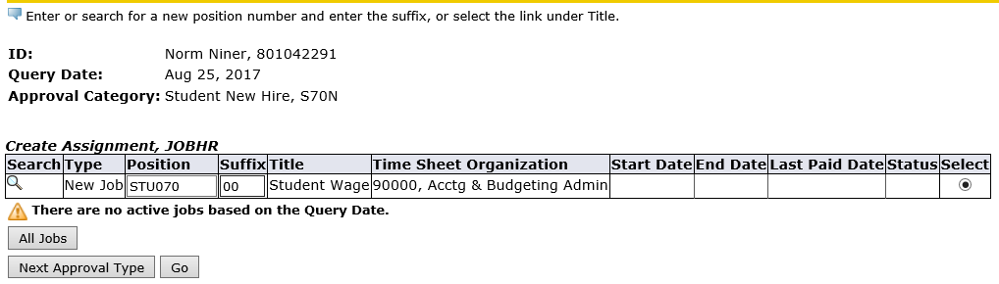
Figure 6 - Create Assignment 2
If this is a rehire, look through the employee’s job record, by clicking on ‘All Jobs’ and find the highest suffix where the position STU070 was used. Then in the ‘New Job’ record, type STU070 for the position, and type the next available suffix for the STU070 position. For example, if the highest suffix for STU070 is 03, you will type 04 when creating the new assignment.
To continue creating a new assignment for the employee, click the Go button.

Completing the EPAF form
On the next screen, you will be presented with the form requiring all the information necessary about the employee’s new job (Figure 7).

Section 1: Employee Information

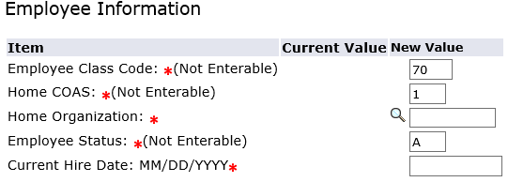
Figure 7 - Entering Base Employee Information

Definitions of Item fields
Employee Class Code | This value indicates the type of temporary job. For this example, we are using 70, which represents a Student Temporary hourly wage. This employee type must complete timesheets and have it approved by their supervisor.
Home COAS | Where the employee will work: currently the only supported value is 1, which indicates UNC Charlotte.
Home Organization | Use the five-digit Banner Organization number for the department this employee will work/assigned access to buildings and drives.
Employee Status | This will always be set to “A” or Active.
Current Hire Date | This is the day the employee will begin work.

Section 2: Job Assignment Information
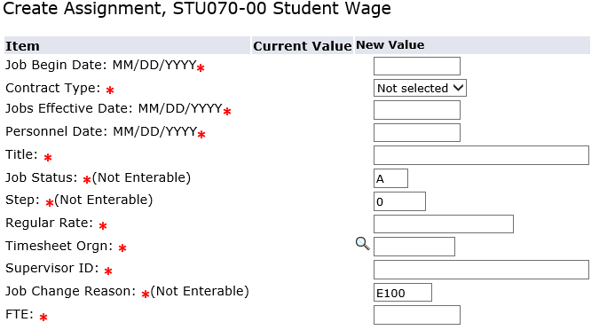
Figure 8 – Create Assignment

Definitions of Item fields
Job Begin Date | For Payroll purposes, this is the first day of the payroll period, based on the employee’s start date. Should match the query date. To select the appropriate pay period, please download the EPAF Submission calendar for payroll dates.
Contract Type | If the employee currently has no other active job, set this field to Primary. If they do have another active job, set this field to Secondary.
Jobs Effective Date | Same as the Job Begin Date.
Personnel Date | This date is when the employee will actually begin work.
Title | The employee’s job title.
Job Status | The employee’s job status. This will always be set to “A” or Active.
Step | Not Used
Regular Rate | The employee’s hourly pay rate. Enter without $ (ex. 7.25)
Timesheet Org | This is the five-digit Banner organization number where this employee will work, should be the same as the Home Organization in the Base Employee Information section.
Supervisor ID | The employees’ supervisor’s ID number.
Job Change Reason | Will always read as E100 if this is a new temporary hire or E102 if this is a reappointment.
FTE | Full Time Equivalent is the number of hours the employee will work per week. Students are limited to 20 hours a less during the academic year. To see the full list of FTEs go to https://hr.charlotte.edu/recruitment-and-hiring/resources-hiring-student-employees  1 hr. -.025 3 hrs. - .075 5 hrs. - .125  8 hrs. - .02 10 hrs. - .25 12 hrs. - .3  15 hrs. - .375 18 hrs. - .45 20 hrs. - .5

Section 3: Job Termination
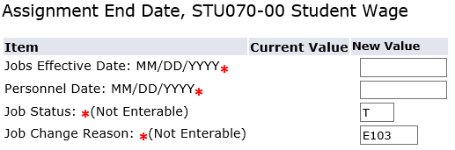
Figure 9 - Entering End Date

Jobs Effective Date | For Payroll purposes, this is the last day of the pay period in which the employee worked. To select the appropriate pay period, please download the EPAF Submission calendar for payroll dates.
Personnel Date | This is the ACTUAL last day of work for the employee.
Job Status | This will always read as T, for Terminated.
Job Change Reason | Will always read E103.

Section 4: Funding Information
On this screen, you must have your fund number and account number available. Type the fund number in the INDEX field on the form, then click the “Default from Index” button below (Figure 10).
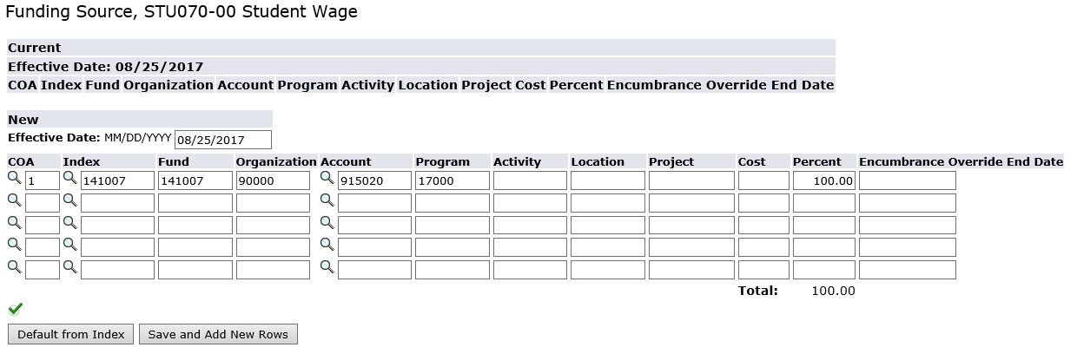
Figure 10- Entering Funding Information

Then retype the account number (915020) into the “Account” field (Figure 11). Use 915040 for Undergraduate Research assignments.
If you submit the EPAF using the default fund number, you will receive an email notification to submit a change request form to submit the appropriate fund number.
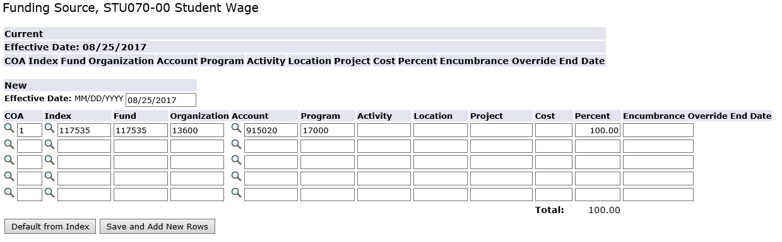
Figure 11 - Entering Funding Information

Section 5: Routing Queue
In this section, you will designate approvers for the EPAF (Figure 12). The appropriate approvers must approve all Student Temporary Hourly Wage EPAF transactions, before they can be applied to the Banner HR database and be added to payroll. Depending on your department’s procedures, you may also need to add additional approvers. At least one approver beyond the initiator is recommended before an action is moved to HR. An approver is a permanent or perhaps a temporary staff employee, who has authority to approve employment actions for that department.
Select the following mandatory approvers for each Student Temporary EPAF:
- Student Employment – Student Employment Coordinator
- Human Resources – AppWorx (BANWORX)
- Payroll – Payroll Manager
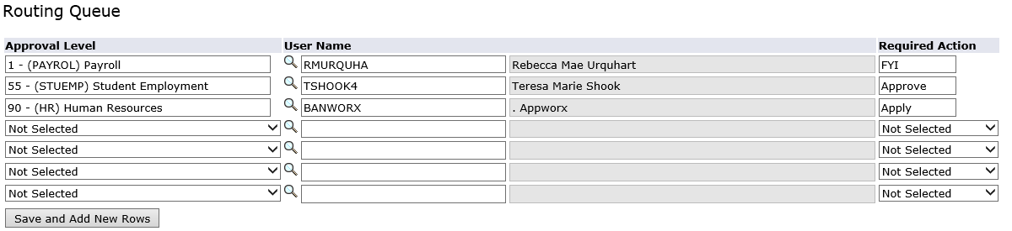

Figure 12 - Routing Queue Information
To add an additional approver, click under approval level and select (DEPT) Department. Then click on the search icon for a pop window of approved User Names. You can also enter their name in the search box and click ‘Go’. Then highlight their name and click ‘Select’. (Figure 13)
Figure 13 – Selecting a Dept. approver
Under ‘Required Action’, chose if they should ‘Approve’ (Figure 14). They can also be listed as FYI, which means they do not have to approve, but can review the EPAF.
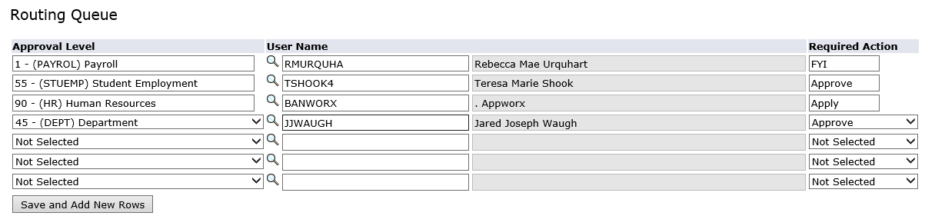
Figure 14 - Routing Queue Information

Section 6: Comments
In the comments section, provide a brief description regarding the employee’s job responsibilities.

Finishing up…
Once the EPAF form is complete, click on the Save button and correct any errors that may appear. Warning messages can be ignored, but you cannot submit the EPAF if there are errors.
If you are able to make the change(s)/corrections(s), add a comment and save. Go back to the current tab and click on the employee’s name. Once your changes are made, click Save, then Submit. If you are unable to make the change(s)/correction(s), you will need to ‘Void’ this EPAF then create a new one.
To see how to fix EPAF Errors, visit https://hr.charlotte.edu/recruitment-and-hiring/resources-hiring-student-employees and click on the common EPAF Errors.

Who to Contact
If you have any questions regarding Student Temporary Wage EPAFs, please contact the Student Employment coordinator at 7-0671 or email studentemployment@uncc.edu. For more information on how to hire a student employee, please go to https://hr.charlotte.edu/recruitment-and-hiring/resources-hiring-student-employees.

Appendix
What a completed EPAF looks like.
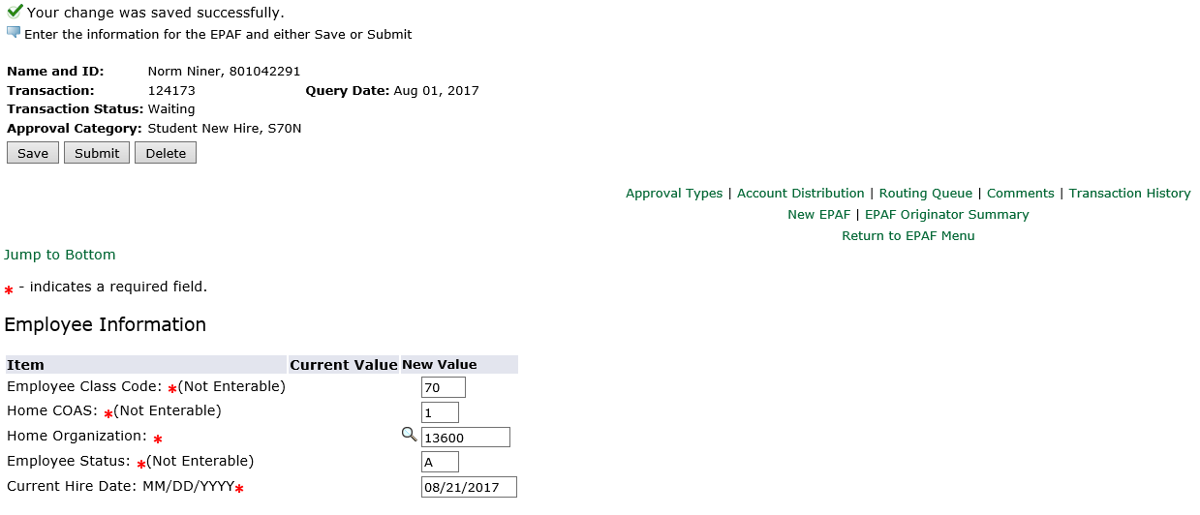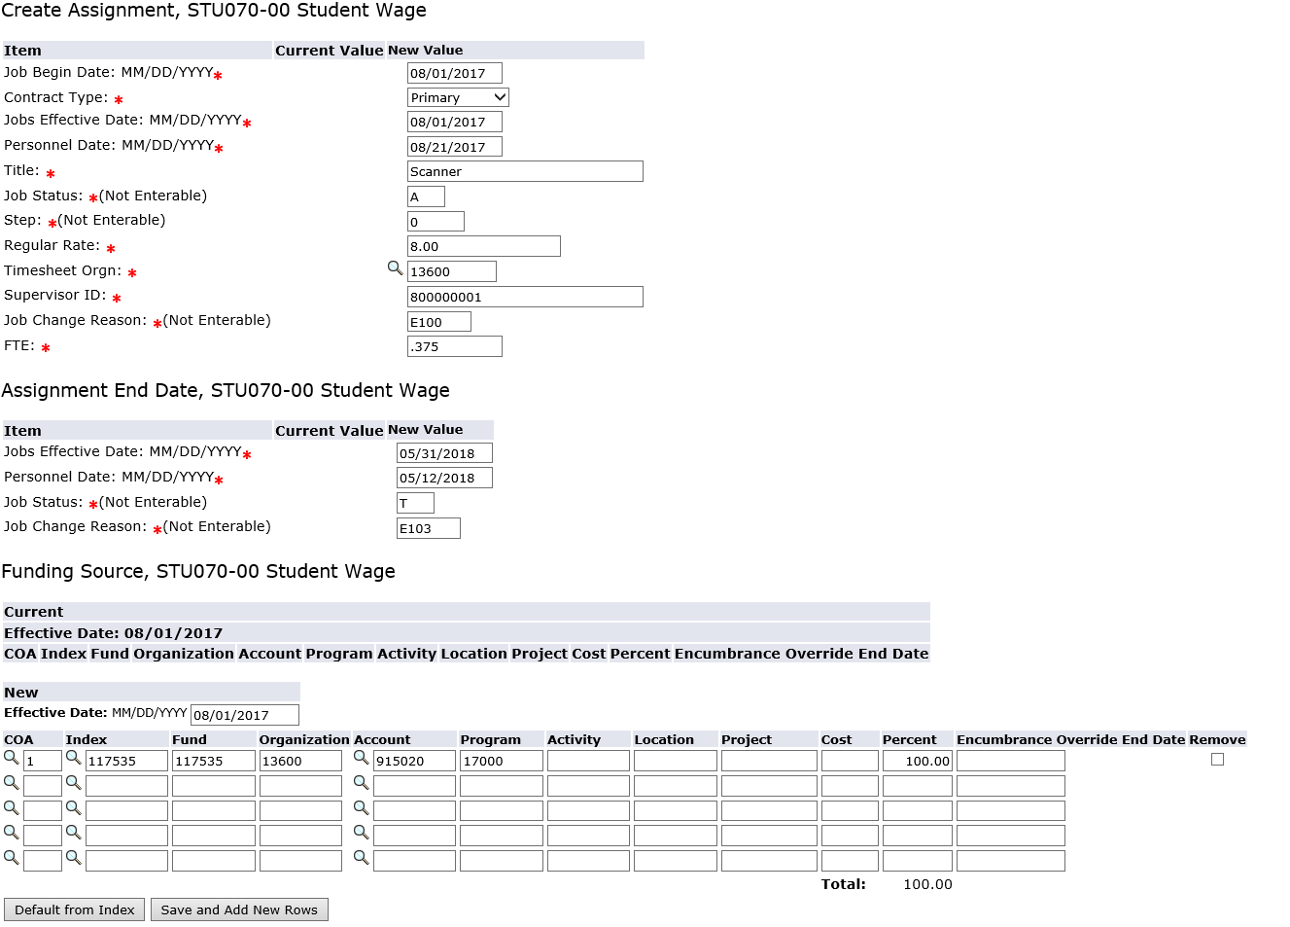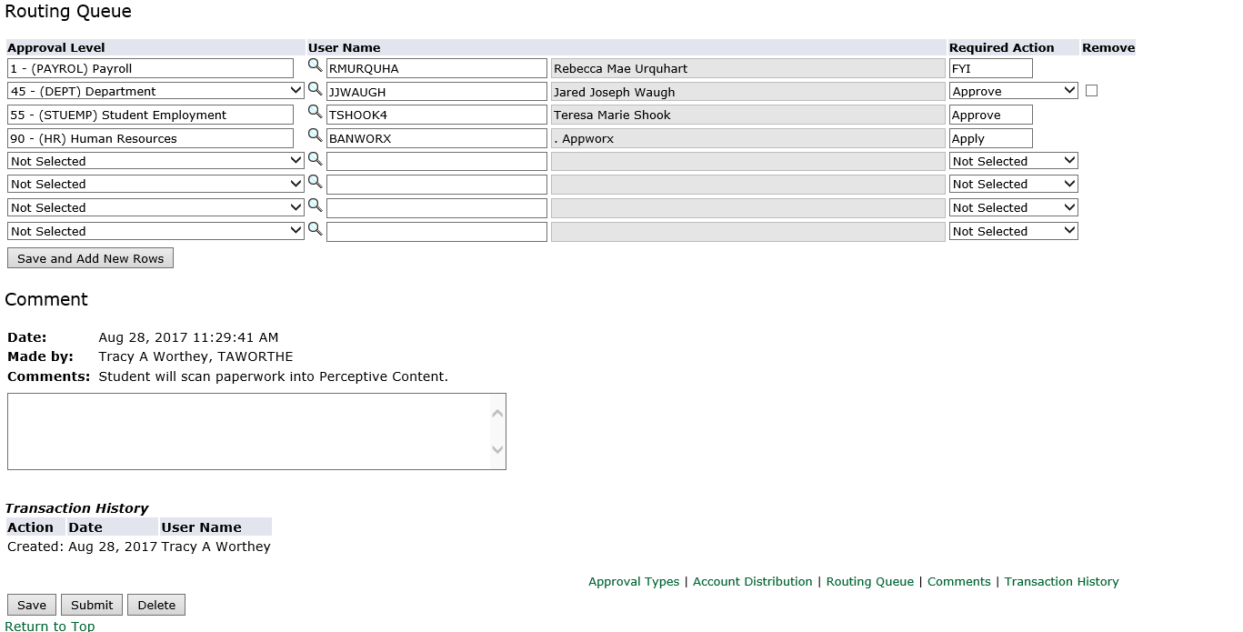
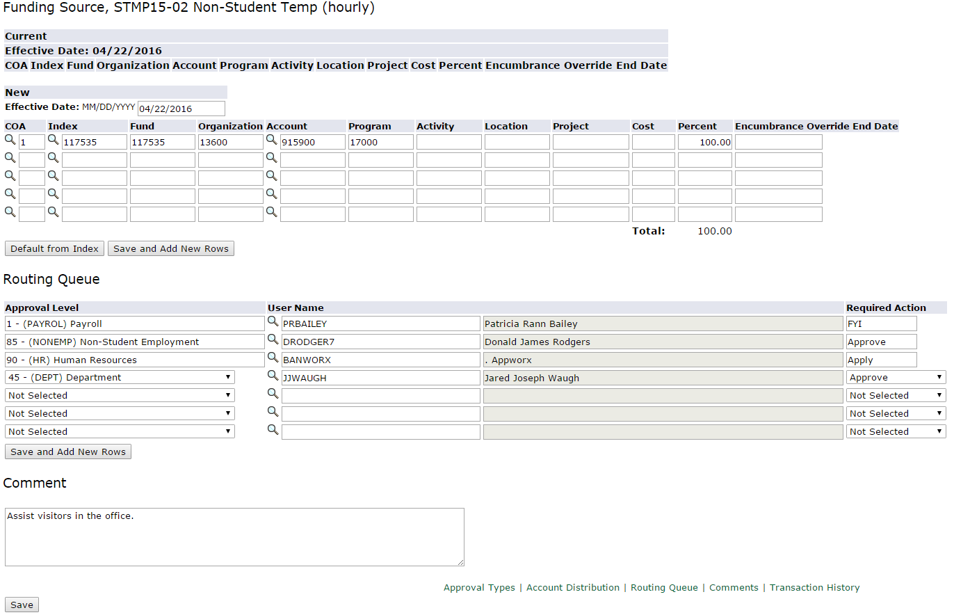

Example of an EPAF when the student has a current job.
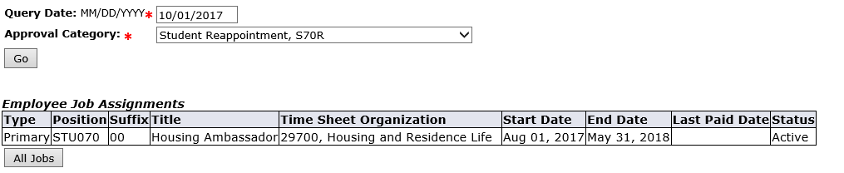
When there is current job, search all jobs for the highest suffix used for that positon type.
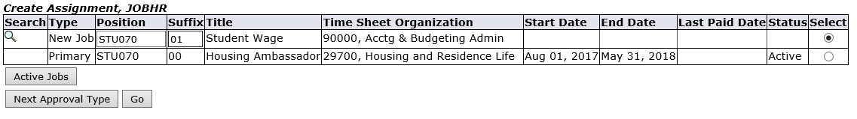
Also, note that you will need to select secondary, when a Primary job is currently active.

This is what you may see when submitting your EPAF.
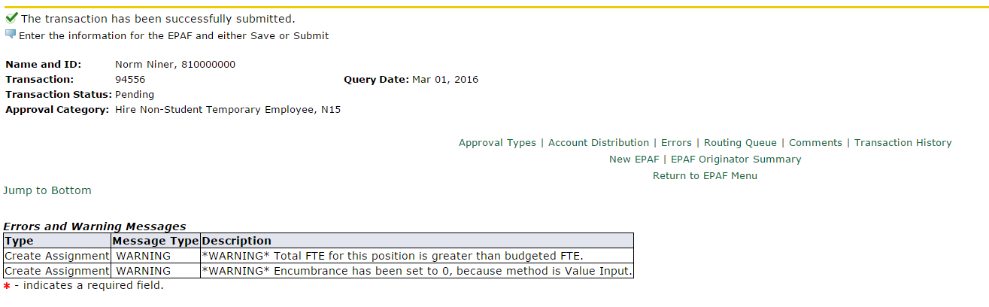
Checking on the status of your EPAF
Click on the History tab to show the status of the EPAF. Under ‘Transaction Status’, to see where your EPAF is in the process.

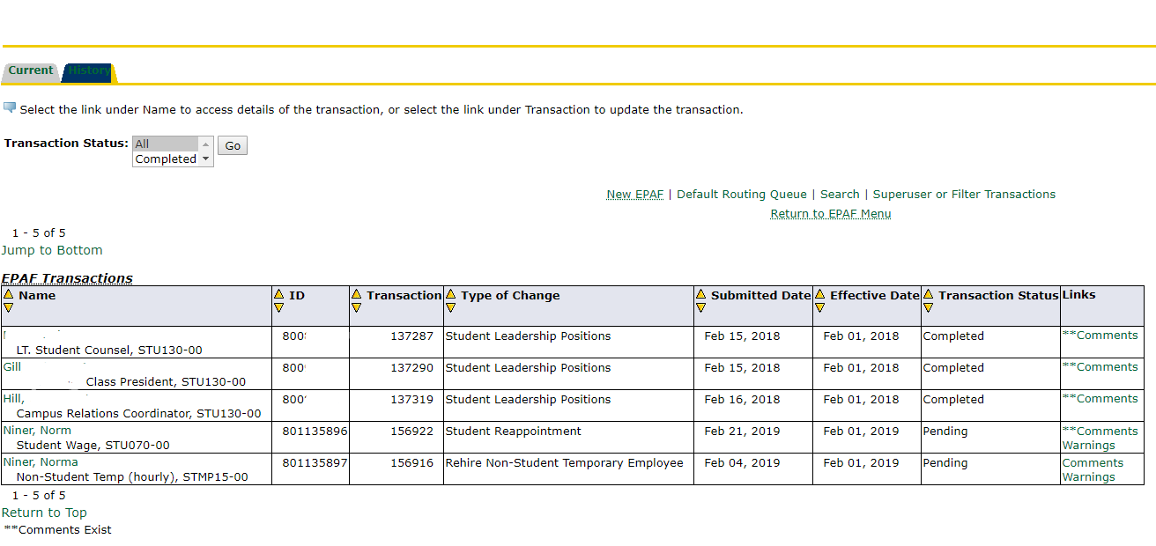

Return for corrections
As you will see this EPAF was retuned for corrections. By clicking on the EPAF originator Summary, it is listed under current history.
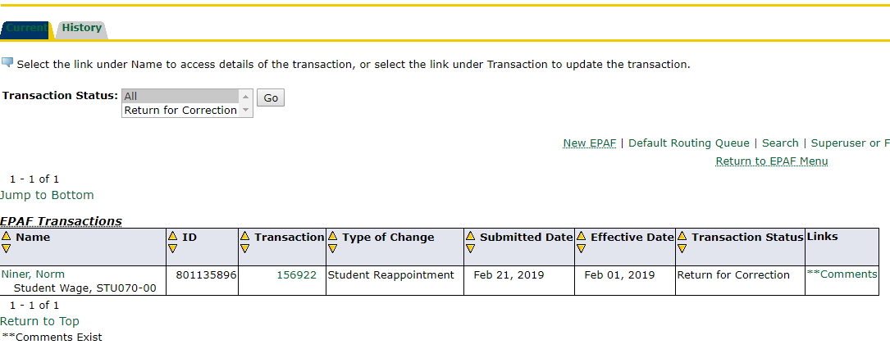

Click on Comments, under the Links box to see the reason for the return.
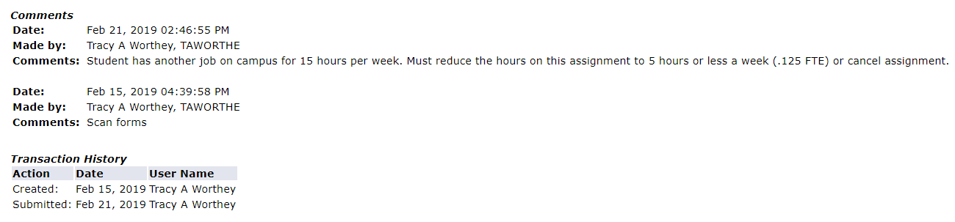

If you are able to make the change(s)/corrections(s), go back to the current tab and click on the employee’s name. 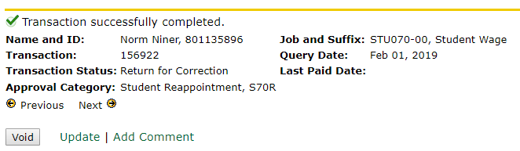
Click on Update to make change(s). Once your change(s) are made, click Save, then Submit.
If you are unable to make the change(s)/correction(s), you will need to ‘Void’ this EPAF then create a new one.

