To Check Status of Your EPAF’s:
- Login in to My UNC Charlotte using your NinerNet Credentials
- Click on Banner Self Service
- On the following page: Click on Employee Information

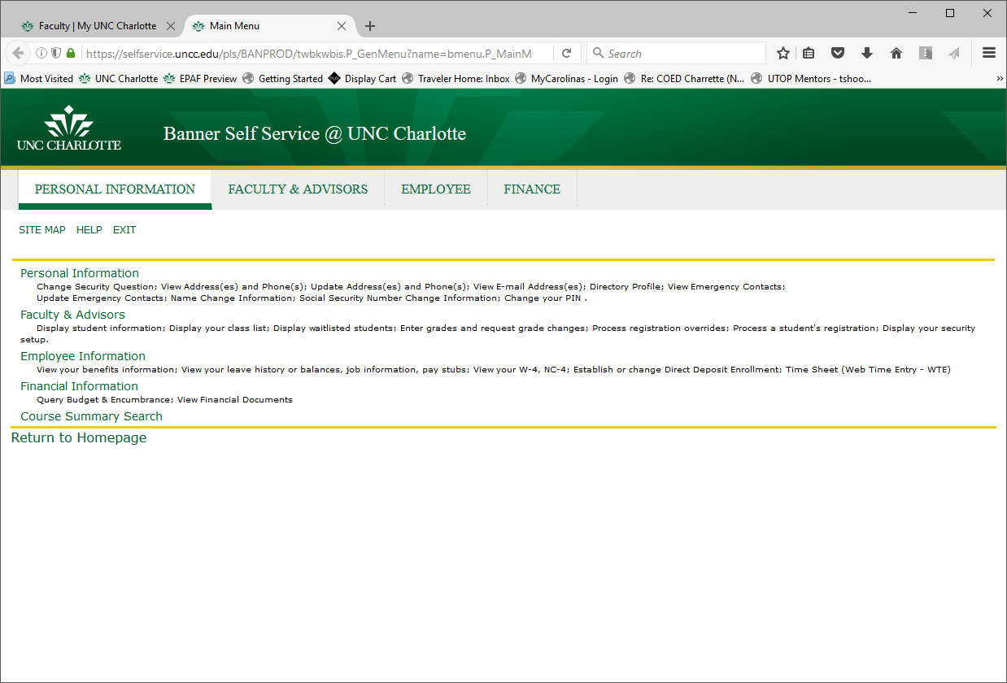

- On this page: Click on EPAF - Electronic Personnel Action Form

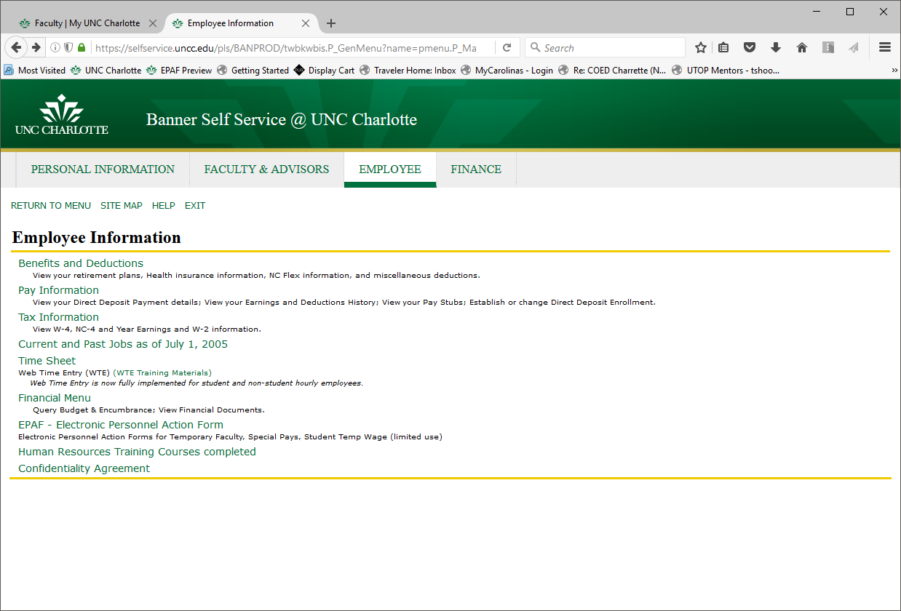

On this page: Click on EPAF Originator Summary

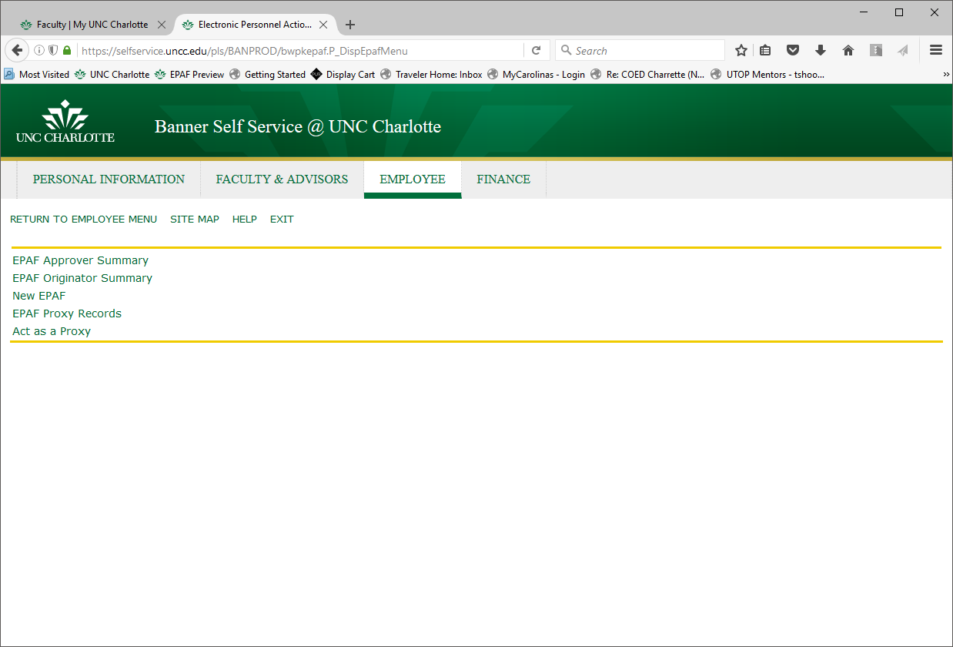

On this page: Click on the History Tab

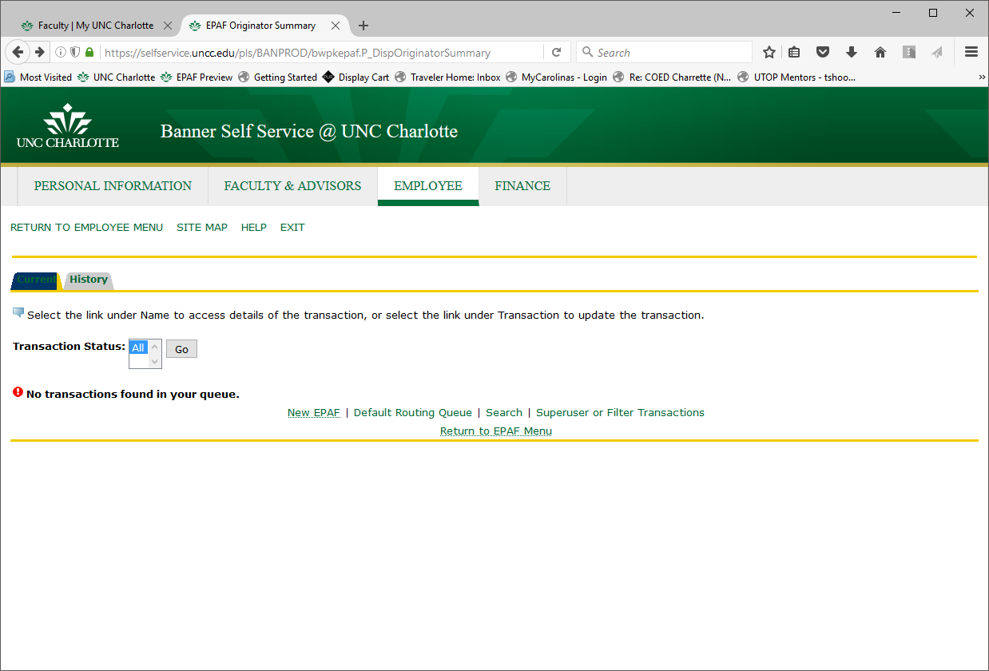

History Page:

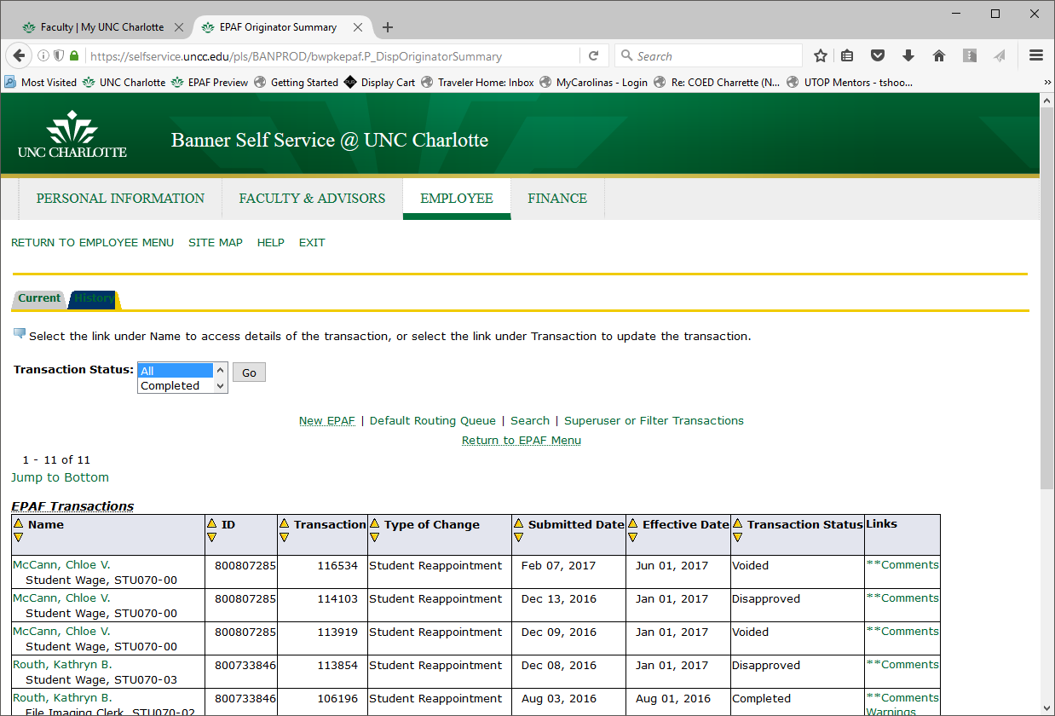

Transaction Statuses and their meanings:

Waiting | EPAF has been created and saved. It needs to be submitted.
Pending | *EPAF is pending in the “Queue Status” of an approver. See screen shot below.
Disapproved | EPAF has been disapproved
Returned for Correction | EPAF has item(s) that need to be corrected
Voided | EPAF has been voided by initiator
Completed | EPAF has been approved by all parties and has been be applied to Banner.
